Daily Email Update Index

2005.08.10

Citigroup news>>Press Release
No | 媒体名称  Publication | 日期  Date | 版面  Page | 发行量  Circulation | 城市  Coverage | 面积  Size | 文章标题  Headline | 基调  Tone | 广告价格  Ad.Equ.
1 | 重庆青年报  Chongqing Youth News | 2005.08.03 | Web | 150,000 | Chongqing | 0 | 全球微型创业奖在中国启动  Global Microentrepreneurship Awards start in China | + | 0
2 | 国际在线  gb.chinabroadcast.cn | 2005.08.03 | Web | 0 | Beijing | 0 | "全球微型企业创业奖"在中国启动 结果11月公布  Winners of Global Microentrepreneurship Awards to be announced this Nov. | + | 0
3 | 搜狐  www.sohu.com | 2005.08.03 | Web | 0 | Beijing | 0 | 花旗集团基金会与UNDP在华启动全球微型创业奖  Citigroup Foundation and UNDP launch Global Microentrepreneurship Awards | + | 0
4 | 新华网  www.xinhuanet.com | 2005.08.03 | Web | 0 | Beijing | 0 | “全球微型创业奖”在中国启动  Global Microentrepreneurship Awards launched in China | + | 0
5 | 北京现代商报  Beijing Business Today | 2005.08.04 | 06 | 130,000 | Beijing | 220 | “全球微型创业奖”在京启动  Global Microentrepreneurship Awards start in Beijing | + | 5,280
6 | 北京日报  Beijing Daily | 2005.08.04 | 11a | 800,000 | Beijing | 52 | 联合国在华启动全球微型创业奖  The United Nations launches Global Microentrepreneurship Awards in China | + | 5,200
7 | 京华时报  Beijing Times | 2005.08.04 | b38b | 400,000 | Beijing | 72 | 微型创业奖  Global Microentrepreneurship Awards | + | 7,560
8 | 第一财经日报  China Business News | 2005.08.04 | b01b | 100,000 | Shanghai | 272 | 联合国倾心中国小额信贷 “全球微型创业奖”锁定目标  The United Nations launches Global Microentrepreneurship Awards | + | 16,320
9 | 中国经济时报  China Economic Times | 2005.08.04 | 01c | 300,000 | Beijing | 126 | “全球微型创业奖”在中国启动  Global Microentrepreneurship Awards start in China | + | 11,214
10 | 经济日报  Economic Daily | 2005.08.04 | 05 | 860,000 | Beijing | 144 | “全球微型创业奖”首次在中国启动  Global Microentrepreneurship Awards start in China for the first time | + | 23,184
11 | 经济参考报  Economic Information Daily | 2005.08.04 | 03f | 400,000 | Beijing | 36 | “全球微型创业奖”启动  Global Microentrepreneurship Awards start | + | 3,960
12 | 农民日报  Farmer's Daily | 2005.08.04 | 02 | 300,000 | Beijing | 45 | “全球微型创业奖”在中国启动  Global Microentrepreneurship Awards start in China | + | 2,835
13 | 国际金融报  International Finance News | 2005.08.04 | 02 | 380,000 | Shanghai | 20 | “全球微型创业奖”启动  Global Microentrepreneurship Awards start | + | 1,300
14 | 证券时报  Securities Times | 2005.08.04 | 04b | 500,000 | Guangdong/  Shenzhen | 48 | “全球微型创业奖”在华首次启动  Global Microentrepreneurship Awards start in China for the first time | + | 6,288
15 | 深圳特区报  Shenzhen Special Zone Daily | 2005.08.04 | c02 | 450,000 | Guangdong/  Shenzhen | 48 | n/a  n/a | + | 6,528
16 | 深圳特区报(当地版)  Shenzhen Special Zone Daily(Local) | 2005.08.04 | c02 | 800,000 | Guangdong/  Shenzhen | 56 | n/a  n/a | + | 7,616
17 | 新京报  The Beijing News | 2005.08.04 | b01 | 400,000 | Beijing | 320 | 联合国在华启动“全球微型创业奖”  The United Nations launches Global Microentrepreneurship Awards | + | 33,600
18 | 新京报  The Beijing News | 2005.08.04 | b04b | 400,000 | Beijing | 64 | 中国首次启动全球微型创业奖  Global Microentrepreneurship Awards start in China | + | 6,720
19 | 网易  www.163.com | 2005.08.04 | Web | 0 | Beijing | 0 | 联合国倾心小额信贷 "全球微型创业奖"锁定目标  The United Nations launches Global Microentrepreneurship Awards | + | 0
20 | donews  www.donews.com | 2005.08.04 | Web | 0 | Guangzhou | 0 | 联合国开发计划署与花旗集团基金会在中国启动“全球微型创业奖”  Citigroup Foundation and UNDP launch Global Microentrepreneurship Awards in China | + | 0
21 | 和讯网  www.hexun.com | 2005.08.04 | Web | 0 | Beijing | 0 | 花旗集团与联合国开发署在中国启动"全球微型创业奖"  Citigroup Foundation and UNDP launch Global Microentrepreneurship Awards in China | + | 0
22 | 全景网  www.p5w.net | 2005.08.04 | Web | 0 | Shenzhen | 0 | 联合国倾心中国小额信贷  United Nations favors Chinese microcredit | + | 0
23 | 全景网  www.p5w.net | 2005.08.04 | Web | 0 | Shenzhen | 0 | “全球微型创业奖”在华首次启动  Global Microentrepreneurship Awards start in China for the first time | + | 0
24 | 新浪  www.sina.com.cn | 2005.08.04 | Web | 0 | Beijing | 0 | 全球微型创业奖在中国启动  GMA begins in China | 0 | 0
25 | 中华工商时报  China Business Times | 2005.08.05 | 03c | 350,000 | Beijing | 60 | “全球微型创业奖”在中国启动  Global Microentrepreneurship Awards start in China | + | 4,620
26 | 中华合作时报  China Cooperation Times | 2005.08.05 | Web | 0 | Beijing | 0 | 小额信贷：精彩不只２００５  ——访联合国开发计划署驻华代表处副代表麦瑞德  Interview with Mr. Renaud Meyer, UNDP deputy resident representative | + | 0
27 | 中华合作时报  China Cooperation Times | 2005.08.05 | 01 | 380,000 | Beijing | 621 | 小额信贷：精彩不只2005  Interview with Renaud Meyer, UNDP deputy resident representative | + | 7,250
28 | 大连晚报  Dalian Evening News | 2005.08.05 | c01b | 350,000 | Liaoning/  Dalian | 75 | 中国首次启动全球微型创业奖  Global Microentrepreneurship Awards start in China | + | 6,225
29 | 中国新闻网  www.chinanews.com.cn | 2005.08.05 | Web | 0 | Beijing | 0 | 联合国开发计划署与花旗启动“全球微型创业奖”  Citigroup Foundation and UNDP launch Global Microentrepreneurship Awards in China | + | 0
30 | 中国经济导报  China Economic Herald | 2005.08.06 | a04a | 110,000 | Beijing | 192 | 鼓励扶贫由“救济式”向“开发式”转变  Encouraging transition from relief-oriented to development-oriented poverty programs | + | 18,048
31 | 证券日报  Securities Daily | 2005.08.07 | a01 | 70,000 | Beijing | 270 | “全球微型企业奖”在中国启动  Global Microentrepreneurship Awards start in China | + | 14,850
32 | 安徽日报  Anhui Daily | 2005.08.08 | c01 | 300,000 | Anhui/  Hefei | 77 | “全球微型创业奖”在中国启动  Global Microentrepreneurship Awards launched in China | + | 7,315
33 | 中国经济周刊  China Economic Weekly | 2005.08.08 | 55 | 100,000 | Beijing | 72 | 中国首次启动全球微型创业奖  Global Microentrepreneurship Awards start in China | + | 5,760
34 | 竞报  The First | 2005.08.08 | Web | 120,000 | Beijing | 0 | “全球微型企业创业奖”在中国启动  Global Microentrepreneurship Awards start in China | + | 0
35 | 中华网  www.china.com | 2005.08.08 | Web | 0 | Beijing | 0 | 联合国开发计划署与花旗集团基金会在中国启动“全球微型创业奖”  UNDP and Citigroup Foundation launch Global Microentrepreneurship Awards in China | + | 0
36 | 中国环境报  China Environmental News | 2005.08.09 | 04a | 250,000 | Beijing | 162 | 小额信贷助力中国扶贫开发  Microfinance helps China's poverty alleviation and development program | + | 7,452
37 | 中国青年报  China Youth Daily | 2005.08.09 | 10 | 1,000,000 | Beijing | 40 | “全球微型创业奖”首次在华启动  Global Microentrepreneurship Awards launched in China for the first time | + | 3,560
38 | 中国青年报  China Youth Daily | 2005.08.09 | Web | 1,000,000 | Beijing | 0 | “全球微型创业奖”首次在华启动  Global Microentrepreneurship Awards launched in China for the first time | + | 0
39 | 经济日报  Economic Daily | 2005.08.09 | 07a | 860,000 | Beijing | 42 | 花旗集团设全球策型创业奖  Citigroup launches Global Microentrepreneurship Awards | + | 6,762

News Clipping from China top

Headline: Global Microentrepreneurship Awards start in China 全球微型创业奖在中国启动
Publication: Chongqing Youth News 重庆青年报
Paper Date: 2005.08.03
Page: http://news.cqqn.com/class/67/2005-08-03/21109.html
Journalist(s): n/a
________________________________________________________________________________________
Summary: Aug.3, Citigroup Foundation and The United Nations Development Programme ("UNDP") announce the commencement of Global Microentrepreneurship Awards ("GMA"). The United Nations has declared 2005 the International Year of Microcredit. The GMA initiative is a key element of this worldwide undertaking.

全球微型创业奖在中国启动
『发布时间:2005-08-03 21:43』
昨日，花旗集团中国区首席执行官施瑞德在北京举行的“全球微型创业奖”新闻发布会上。当日，联合国开发计划署和花旗集团基金会在北京联合宣布，由花旗集团基金会提供专款的旨在对中国杰出的微型创业者进行表彰的“全球微型创业奖”活动在中国正式启动。联合国宣布2005年为国际小额信贷年，“全球微型创业奖”活动为其主要活动之一，今年实施的“全球微型创业奖”活动将在34个国家和地区举行。

News Clipping from China top

Headline: Winners of Global Microentrepreneurship Awards to be announced this Nov. "全球微型企业创业奖"在中国启动 结果11月公布
Publication: gb.chinabroadcast.cn 国际在线
Paper Date: 2005.08.03
Page: http://gb.chinabroadcast.cn/3821/2005/08/03/107@647075.htm
Journalist(s): Zhu Jianying
________________________________________________________________________________________
Summary: Aug. 3, the Citigroup Foundation and the United Nations Development Program ("UNDP") today launches the first-ever Global Microentrepreneurship Awards ("GMA") in China. The awards will be presented in nine categories, with the winners to be announced on Nov. 8, 2005. The grant from the Citigroup Foundation will be put towards the implementation of the GMA program as well as the prize money.

"全球微型企业创业奖"在中国启动 结果11月公布
2005-08-03

国际在线消息（记者朱建英）8月3日，联合国开发计划署与花旗集团基金会在中国首次启动了"全球微型企业奖"项目。该项目在中国共设九类奖项，由专门组成的评审委员会对中国345家小额信贷机构有杰出表现的客户和贷款专员进行评审，评审结果将在今年11月8日公布，这项活动的资金是由花旗集团基金会提供的。

"全球微型创业奖"在中国的目标是提升对微型创业者及其融资需要的认识，奖励他们对家庭和当地社区所做出的经济贡献。今年是联合国指定的国际小额信贷年，"全球微型创业奖"是此项全球事业的关键组成部分，该项目将在中国、印度、俄罗斯、巴西等34个国家举行。

News Clipping from China top

Headline: Citigroup Foundation and UNDP launch Global Microentrepreneurship Awards 花旗集团基金会与UNDP在华启动全球微型创业奖
Publication: www.sohu.com 搜狐
Paper Date: 2005.08.03
Page: http://business.sohu.com/20050803/n240220375.shtml
Journalist(s): n/a
________________________________________________________________________________________
Summary: Aug.3, Citigroup Foundation and The United Nations Development Programme ("UNDP") today launched the first-ever Global Microentrepreneurship Awards ("GMA") in China to recognize and support the entrepreneurial skills and resolve of some of the country's most outstanding microentrepreneurs. The United Nations has declared 2005 the International Year of Microcredit in an effort to promote more inclusive financial sectors around the globe. The GMA initiative is a key element of this worldwide undertaking. Mr. Richard Stanley, CEO of Citigroup China, noted, "Citigroup is strongly committed to playing a role in China's future, and actively supports microfinance in China, which we believe is of proven value in the fight to eradicate poverty and raise living standards. We are committed to encouraging and recognizing the role of microfinance in China's ongoing social and economic development through this awards program."

花旗集团基金会与UNDP在华启动全球微型创业奖
2005年08月03日
花旗集团基金会与联合国开发计划署在中国启动“全球微型创业奖”
搜狐财经讯 2005年8月3日，北京：花旗集团基金会和联合国开发计划署（UNDP）今天在中国首次启动了“全球微型创业奖”（GMA），旨在对中国最杰出的微型创业者的创业技能和决心表示认可和赞赏。联合国宣布2005年为国际小额信贷年，以促进全球金融行业的多样化发展。“全球微型创业奖”活动是此项全球事业的关键组成部分。
“全球微型创业奖”在中国的目标是提升对微型创业者及其融资需要的认识，展现他们对家庭和当地社区所做出的重要经济贡献。
此外，“全球微型创业奖”在中国的开展，尤其希望强调建设多样化金融行业对于解决中国在建设和谐社会道路上所面临的发展不平衡问题的重要性。
“全球微型创业奖”在中国的组织工作，由联合国开发计划署、花旗集团、联合国儿童基金会、“全球微型创业奖”学生同盟和小额信贷促进网络组成的工作小组负责。“全球微型创业奖”在中国共设九类奖项，将于2005年11月8日宣布获奖者名单。
中国人民银行副行长吴晓灵表示：“我们认为，小额信贷在中国仍不失为微型金融服务中由救济式扶贫向开发式扶贫转变的一次革命性的政策转变，是解决贫困阶层脱贫致富进而奔小康最终实现共同富裕的重要途径。小额信贷调动了全社会参与扶贫的热情和积极性，受到了广大贫困阶层的热烈欢迎。因此，小额信贷在中国有获得成功的政策保障和牢固的群众基础。以反贫困、促发展为宗旨的小额信贷是解决中国小企业发展和农民多种经营资金需求的有效方式，也是发展劳动密集型企业、扩大就业的有效途径，中国人民银行将在国务院的领导下，与相关部门配合，大力推进这一工作的开展。”
“全球微型创业奖”计划由联合国开发计划署与花旗集团的慈善分支——花旗集团基金会提供支持。由花旗集团基金会提供的专款将用于“全球微型创业奖”计划的实施和奖金发放。
花旗集团中国区首席执行官施瑞德(Richard Stanley)先生说：“在中国未来建设的进程中，花旗集团一直致力于发挥自己的作用，而且一直在积极支持中国的小额信贷事业。我们相信小额信贷，这一被证明有效的方法与途径，将有助于消除贫困和提高生活水平。我们希望通过此项活动，对于小额信贷在中国社会和经济发展中的积极作用给予鼓励和认可。”
“全球微型创业奖”计划还特别得到顾问委员会的支持，其重要成员包括中国人民银行副行长吴晓灵、商务部副部长魏建国、中华全国妇女联合会秘书长甄砚、著名经济学家吴敬琏和著名经济学家茅于轼。
“全球微型创业奖”邀请函连同申请表已经发往345家小额信贷机构（MFI），要求其代表表现杰出的重要客户，以及在支持客户需求方面做出卓越贡献的贷款专员，提交详细的申请表。
符合基本参赛条件的参赛者将分九大类别进行角逐：乡村种植业、乡村养殖业、乡村非农业、城市贸易、城市加工业、城市服务业、乡村信贷员、城市信贷员，以及一个特殊奖项：最具创意微型创业者奖。
几轮筛选过后，最终获奖者将由评选委员会选出。评选委员会由多位在中国小额信贷领域具备丰富经验的重要人士组成，其中包括中国人民银行金融监管部主管徐忠、国务院扶贫办公室政策研究所研究员苏国霞、中华全国妇女联合会妇女发展部主任崔玉、中国人民大学农业与农村发展学院教授温铁军、亚洲发展银行驻华代表汤敏、福特基金会中国办事处代表Andrew Watson和花旗集团中国区国家风险经理林铭恩女士。
联合国开发计划署驻华副代表麦瑞德 (Renaud Meyer) 先生说：“据估计，在可能因小额信贷而受益的10亿低收入贫困人群中，有90%得不到基本的金融服务。他们每个人与我们所有人一样都拥有技术、思想和梦想，但他们却没有机会将这些变成现实。小额信贷能有如此巨大的力量，正是由于它能够使贫困人群潜在的创业精神得到释放，并使他们依靠自己的力量走出贫困。“全球微型创业奖”计划的重要性在于，它将成功的微型创业者放在舞台的中心，使他们证明小额信贷如何能让贫困人群获得力量，并发挥全世界贫困地区存在的创业精神。”
联合国开发计划署
联合国开发计划署是联合国从事发展的机构。我们注重消除贫困，倡导变革，为各国提供知识、经验和资源，以帮助人们建设美好的生活。我们帮助发展中国家吸引和有效地使用国际援助，致力于在全世界实现可持续发展。联合国开发计划署跟踪、统计各国实现千年发展目标的状况，连接和协调全球以及各国为实现这些目标而做出的努力。
花旗集团
花旗在中国的历史可追溯至1902年5月。如今，花旗已是中国顶尖外资银行，为客户提供最广泛的金融产品。目前，花旗在北京、上海、广州、深圳和天津设立5家企业与投资银行分行；同时有9家个人零售银行营业网点；在厦门和成都建立代表处；中国区总部也设在上海浦东。作为花旗集团在全球100多个国家网络的一部分，花旗银行已成为在中国最具全球性的外资银行。如需其他讯息，请访问www.citigroup.com / www.citibank.com.cn

News Clipping from China top

Headline: Global Microentrepreneurship Awards launched in China “全球微型创业奖”在中国启动
Publication: www.xinhuanet.com 新华网
Paper Date: 2005.08.03
Page: http://news.xinhuanet.com/photo/2005-08/03/content_3305051.htm
Journalist(s): n/a
________________________________________________________________________________________
Summary: Aug. 3, Citigroup Foundation and The United Nations Development Programme ("UNDP") announce the commencement of Global Microentrepreneurship Awards ("GMA"). The United Nations has declared 2005 the International Year of Microcredit. The GMA initiative is a key element of this worldwide undertaking.

“全球微型创业奖”在中国启动
2005年08月03日
8月3日，花旗集团中国区首席执行官施瑞德在北京举行的“全球微型创业奖”新闻发布会上。当日，联合国开发计划署和花旗集团基金会在北京联合宣布，由花旗集团基金会提供专款的旨在对中国杰出的微型创业者进行表彰的“全球微型创业奖”活动在中国正式启动。联合国宣布2005年为国际小额信贷年，“全球微型创业奖”活动为其主要活动之一，今年实施的“全球微型创业奖”活动将在34个国家和地区举行。

News Clipping from China top

Headline: Global Microentrepreneurship Awards start in Beijing “全球微型创业奖”在京启动
Publication: Beijing Business Today 北京现代商报
Paper Date: 2005.08.04
Page: 06
Journalist(s): Du Gang
________________________________________________________________________________________
Summary: Citigroup Foundation and The United Nations Development Programme ("UNDP") yesterday (Aug.3) launched the first-ever Global Microentrepreneurship Awards ("GMA") in China to recognize and support the entrepreneurial skills and resolve of some of the country's most outstanding microentrepreneurs. The United Nations has declared 2005 the International Year of Microcredit in an effort to promote more inclusive financial sectors around the globe.

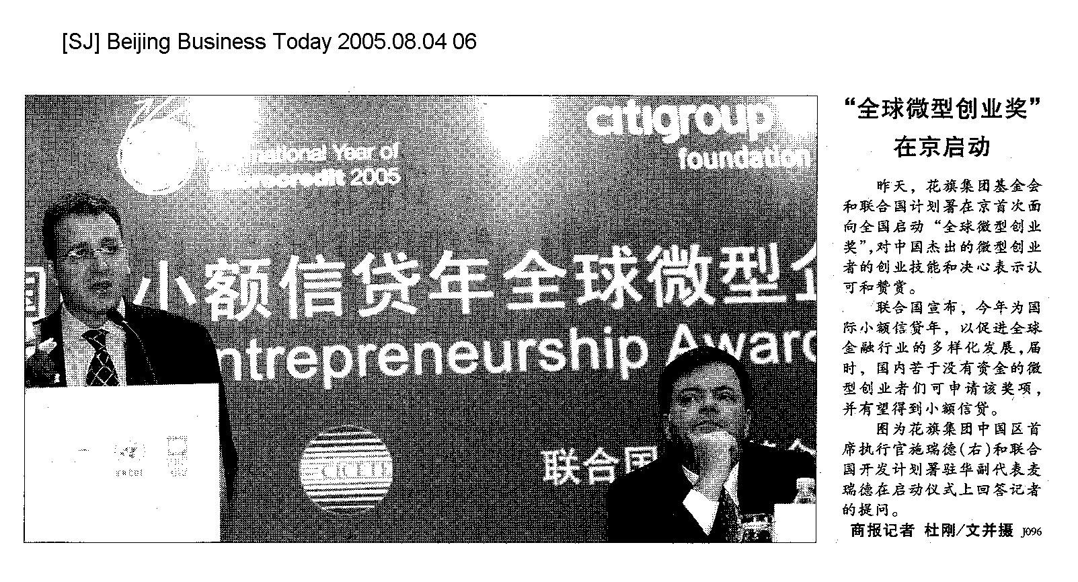

News Clipping from China top

Headline: The United Nations launches Global Microentrepreneurship Awards in China 联合国在华启动全球微型创业奖
Publication: Beijing Daily 北京日报
Paper Date: 2005.08.04
Page: 11a
Journalist(s): Geng Caiqin
________________________________________________________________________________________
Summary: The United Nations Development Programme ("UNDP") and Citigroup Foundation yesterday launched the first-ever Global Microentrepreneurship Awards ("GMA") in China to recognize and support the entrepreneurial skills and resolve of some of the country's most outstanding microentrepreneurs. The United Nations has declared 2005 the International Year of Microcredit in an effort to promote more inclusive financial sectors around the globe. The GMA initiative is a key element of this worldwide undertaking. Awards will be presented in nine categories,with the winners announced on Nov. 8, 2005.

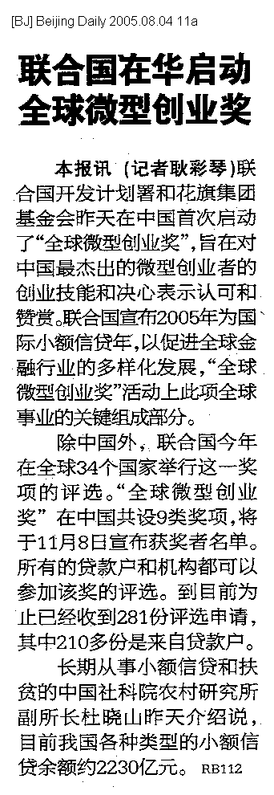

News Clipping from China top

Headline: Global Microentrepreneurship Awards 微型创业奖
Publication: Beijing Times 京华时报
Paper Date: 2005.08.04
Page: b38b
Journalist(s): Xinhua reporter Chen Jianli
________________________________________________________________________________________
Summary: Aug.3, Richard Stanley, CEO of Citigroup China, holds a press conference to announce the commencement of Global Microentrepreneurship Awards ("GMA") in China. The GMA program is being supported by the Citigroup Foundation.

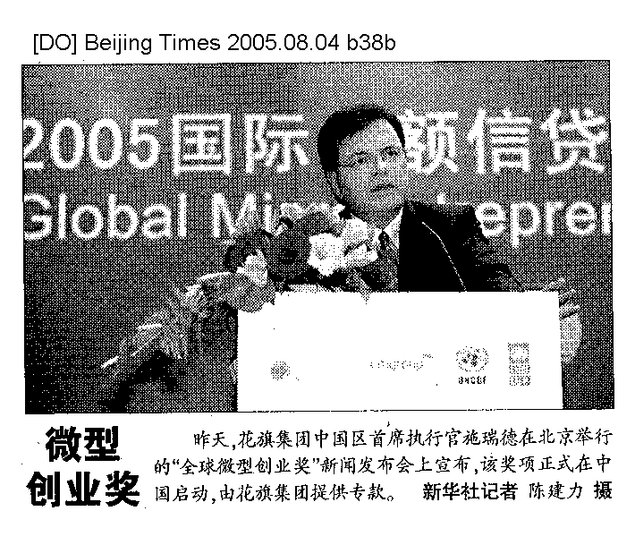

News Clipping from China top

Headline: The United Nations launches Global Microentrepreneurship Awards 联合国倾心中国小额信贷 “全球微型创业奖”锁定目标
Publication: China Business News 第一财经日报
Paper Date: 2005.08.04
Page: b01b
Journalist(s): Tang Kun
________________________________________________________________________________________
Summary: Aug.3, Citigroup Foundation and The United Nations Development Programme ("UNDP") today launched the first-ever Global Microentrepreneurship Awards ("GMA") in China to recognize and support the entrepreneurial skills and resolve of some of the country's most outstanding microentrepreneurs. The United Nations has declared 2005 the International Year of Microcredit in an effort to promote more inclusive financial sectors around the globe. The GMA initiative is a key element of this worldwide undertaking.

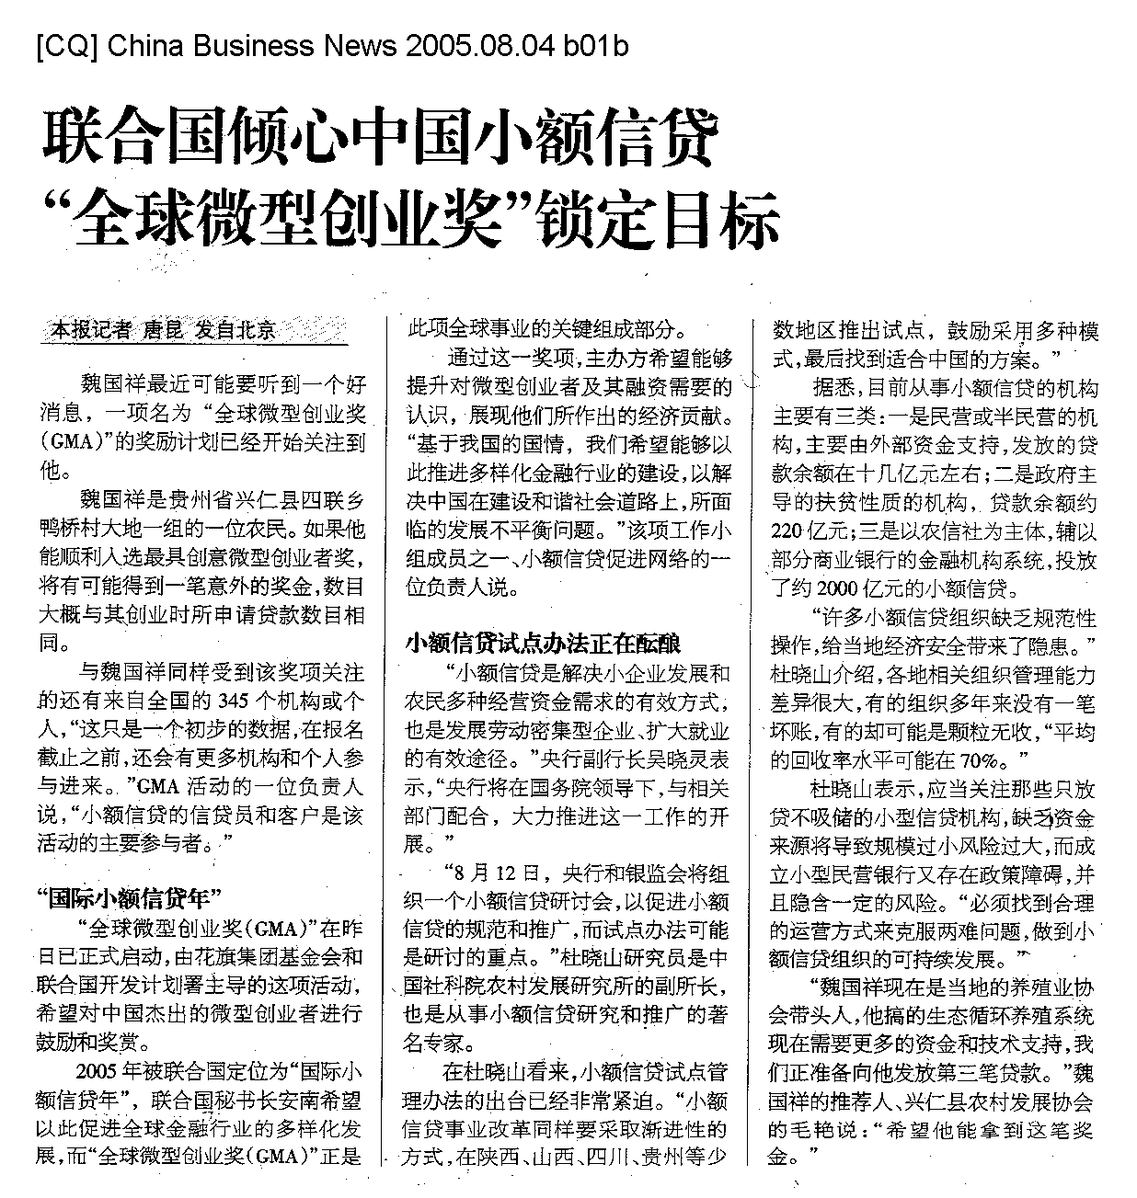

News Clipping from China top

Headline: Global Microentrepreneurship Awards start in China “全球微型创业奖”在中国启动
Publication: China Economic Times 中国经济时报
Paper Date: 2005.08.04
Page: 01c
Journalist(s): Shan Yuqing
________________________________________________________________________________________
Summary: Aug. 3, Citigroup Foundation and The United Nations Development Programme ("UNDP") launches the first-ever Global Microentrepreneurship Awards ("GMA") in China. The United Nations has declared 2005 the International Year of Microcredit in an effort to promote more inclusive financial sectors around the globe. The GMA initiative is a key element of this worldwide undertaking. The GMA program is being supported by the UNDP and Citigroup Foundation, the philanthropic arm of Citigroup. Awards will be presented in nine categories, with the winners announced on Nov. 8, 2005.

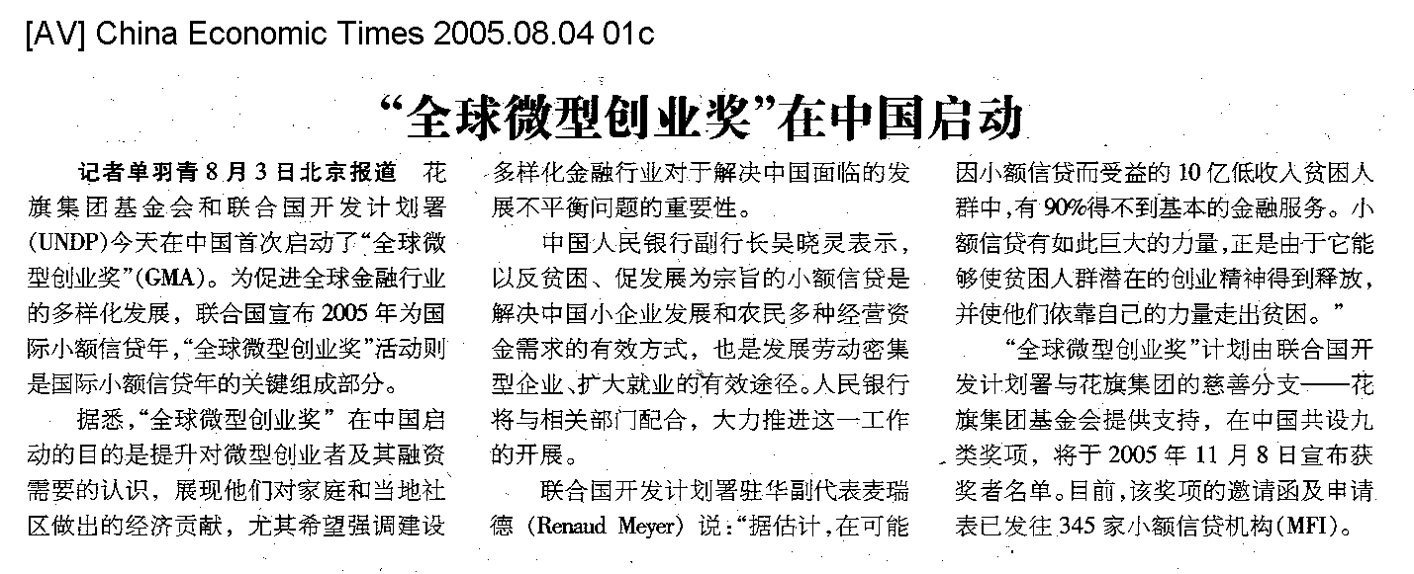

News Clipping from China top

Headline: Global Microentrepreneurship Awards start in China for the first time “全球微型创业奖”首次在中国启动
Publication: Economic Daily 经济日报
Paper Date: 2005.08.04
Page: 05
Journalist(s): Zhao Xiaoqiang
________________________________________________________________________________________
Summary: Aug.3, Citigroup Foundation and The United Nations Development Programme ("UNDP") today launched the first-ever Global Microentrepreneurship Awards ("GMA") in China to recognize and support the entrepreneurial skills and resolve of some of the country's most outstanding microentrepreneurs. The United Nations has declared 2005 the International Year of Microcredit in an effort to promote more inclusive financial sectors around the globe. The GMA initiative is a key element of this worldwide undertaking.

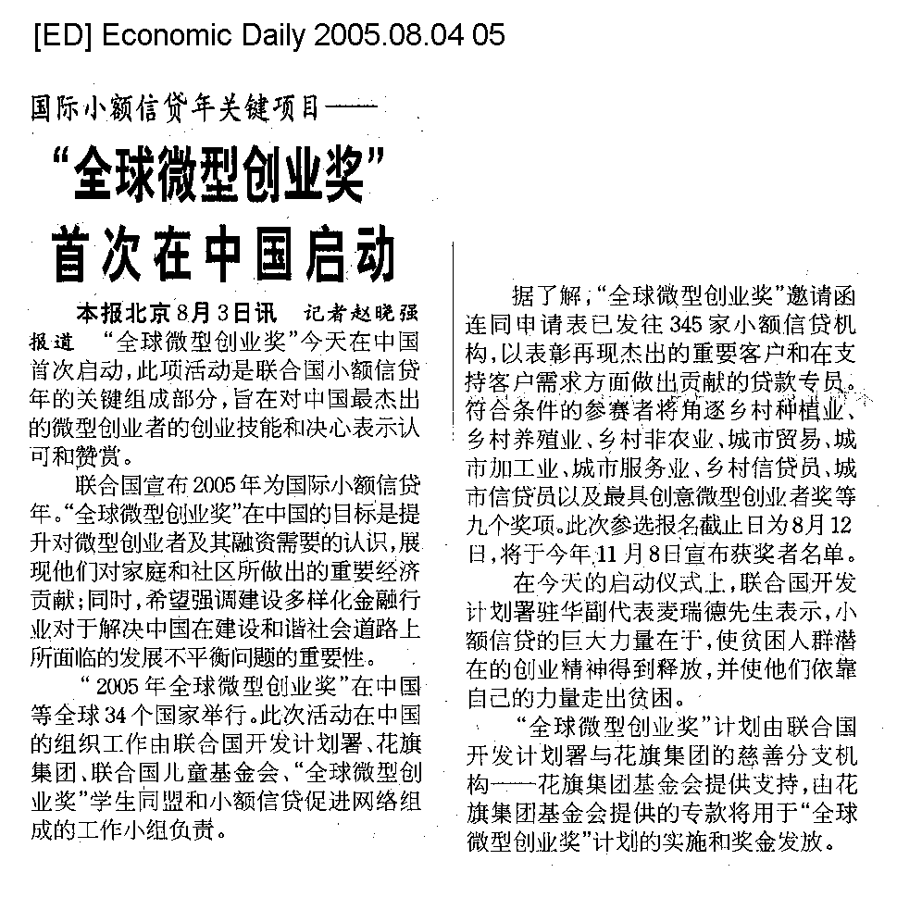

News Clipping from China top

Headline: Global Microentrepreneurship Awards start “全球微型创业奖”启动
Publication: Economic Information Daily 经济参考报
Paper Date: 2005.08.04
Page: 03f
Journalist(s): Fang Ye
________________________________________________________________________________________
Summary: Aug.3, Citigroup Foundation and The United Nations Development Programme ("UNDP") today launched the first-ever Global Microentrepreneurship Awards ("GMA") in China. Awards will be presented in nine categories, with the winners announced on Nov. 8, 2005.

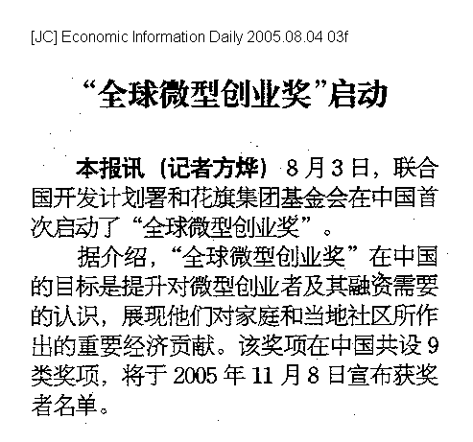

News Clipping from China top

Headline: Global Microentrepreneurship Awards start in China “全球微型创业奖”在中国启动
Publication: Farmer's Daily 农民日报
Paper Date: 2005.08.04
Page: 02
Journalist(s): Zheng Zhi
________________________________________________________________________________________
Summary: Aug. 3, Citigroup Foundation and The United Nations Development Programme ("UNDP") today launched the first-ever Global Microentrepreneurship Awards ("GMA") in China to recognize and support the entrepreneurial skills and resolve of some of the country's most outstanding microentrepreneurs. Awards will be presented in nine categories, with the winners announced on Nov. 8, 2005.

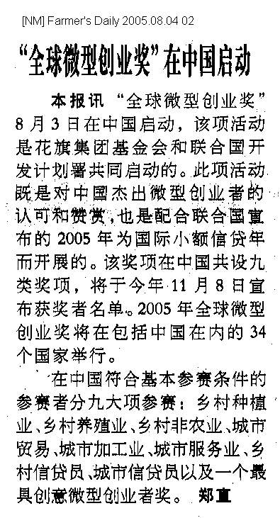

News Clipping from China top

Headline: Global Microentrepreneurship Awards start “全球微型创业奖”启动
Publication: International Finance News 国际金融报
Paper Date: 2005.08.04
Page: 02
Journalist(s): Li Meiying
________________________________________________________________________________________
Summary: Aug. 3, the Citigroup Foundation and the United Nations Development Program ("UNDP") announce the commencement of the Global Microentrepreneurship Awards ("GMA").

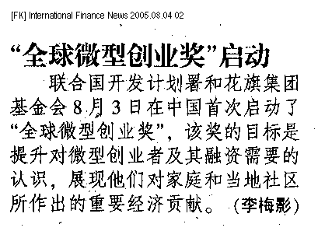

News Clipping from China top

Headline: Global Microentrepreneurship Awards start in China for the first time “全球微型创业奖”在华首次启动
Publication: Securities Times 证券时报
Paper Date: 2005.08.04
Page: 04b
Journalist(s): Liu Yang
________________________________________________________________________________________
Summary: Citigroup Foundation and The United Nations Development Programme ("UNDP") yesterday (Aug.3) launched the first-ever Global Microentrepreneurship Awards ("GMA") in China to recognize and support the entrepreneurial skills and resolve of some of the country's most outstanding microentrepreneurs. The United Nations has declared 2005 the International Year of Microcredit in an effort to promote more inclusive financial sectors around the globe. The GMA initiative is a key element of this worldwide undertaking.

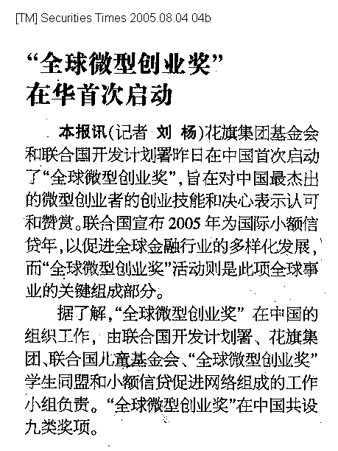

News Clipping from China top

Headline: n/a n/a
Publication: Shenzhen Special Zone Daily 深圳特区报
Paper Date: 2005.08.04
Page: c02
Journalist(s): Xinhua
________________________________________________________________________________________
Summary: Aug. 3, the Global Microentrepreneurship Awards ("GMA") is officially launched in China, which is being supported by the Citigroup Foundation.

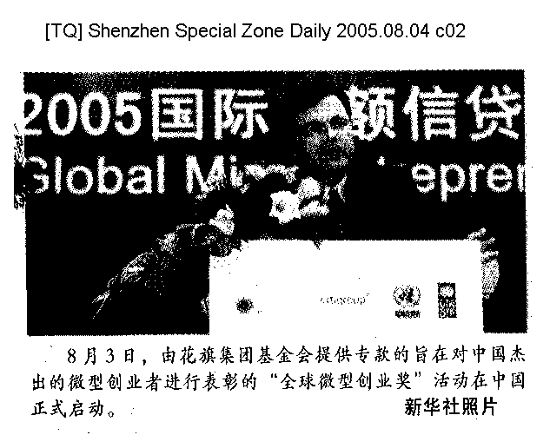

News Clipping from China top

Headline: n/a n/a
Publication: Shenzhen Special Zone Daily(Local) 深圳特区报(当地版)
Paper Date: 2005.08.04
Page: c02
Journalist(s): Xinhua reporter
________________________________________________________________________________________
Summary: Aug. 3, the Global Microentrepreneurship Awards ("GMA") are launched in China, supported by the Citigroup Foundation.

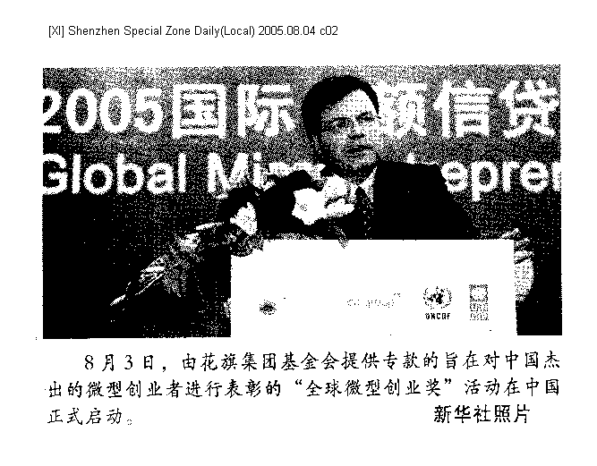

News Clipping from China top

Headline: The United Nations launches Global Microentrepreneurship Awards 联合国在华启动“全球微型创业奖”
Publication: The Beijing News 新京报
Paper Date: 2005.08.04
Page: b01
Journalist(s): Han Meng
________________________________________________________________________________________
Summary: Citigroup Foundation and The United Nations Development Programme ("UNDP") yesterday (Aug.3) launched the first-ever Global Microentrepreneurship Awards ("GMA") in China. Awards will be presented in nine categories, with the winners announced on Nov. 8. 2005. The United Nations has declared 2005 the International Year of Microcredit. The GMA initiative is a key element of this worldwide undertaking.

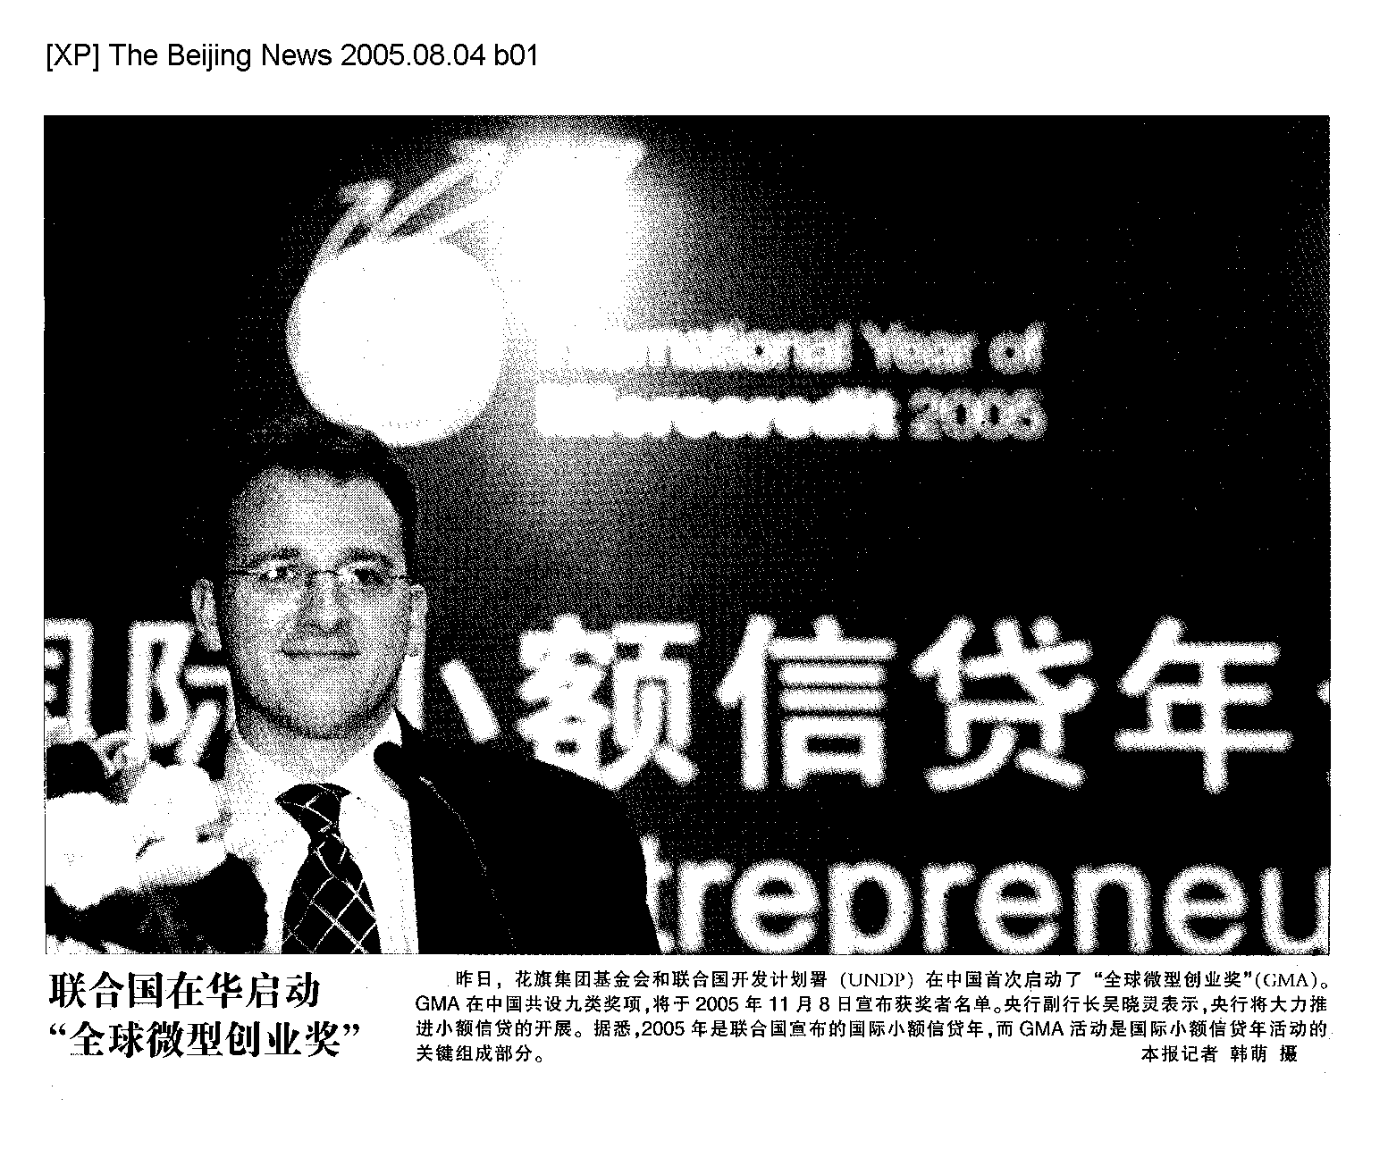

News Clipping from China top

Headline: Global Microentrepreneurship Awards start in China 中国首次启动全球微型创业奖
Publication: The Beijing News 新京报
Paper Date: 2005.08.04
Page: b04b
Journalist(s): Zhuang Shiguan
________________________________________________________________________________________
Summary: Aug.3, Citigroup Foundation and The United Nations Development Programme ("UNDP") launch the first-ever Global Microentrepreneurship Awards ("GMA") in China. Awards will be presented in nine categories, with the winners announced on Nov. 8, 2005. The United Nations has declared 2005 the International Year of Microcredit. The GMA initiative is a key element of this worldwide undertaking. In China, the GMA is facilitated by a multi-member team consisting of UNDP, Citigroup, UNICEF, the GMA Student Alliance, and the Microfinance Promotion Network.

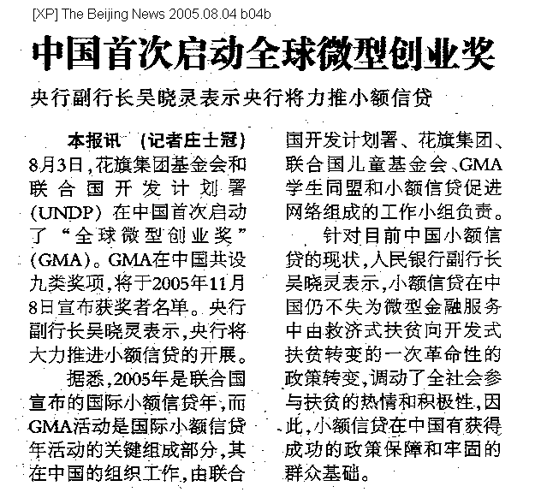

News Clipping from China top

Headline: The United Nations launches Global Microentrepreneurship Awards 联合国倾心小额信贷 "全球微型创业奖"锁定目标
Publication: www.163.com 网易
Paper Date: 2005.08.04
Page: http://biz.163.com/05/0804/05/1Q9N71GU00020QFC.html
Journalist(s): Tang Kun
________________________________________________________________________________________
Summary: Aug.3, Citigroup Foundation and The United Nations Development Programme ("UNDP") today launched the first-ever Global Microentrepreneurship Awards ("GMA") in China to recognize and support the entrepreneurial skills and resolve of some of the country's most outstanding microentrepreneurs. The United Nations has declared 2005 the International Year of Microcredit in an effort to promote more inclusive financial sectors around the globe. The GMA initiative is a key element of this worldwide undertaking.

联合国倾心小额信贷 "全球微型创业奖"锁定目标 联合国倾心小额信贷 "全球微型创业奖"锁定目标
http://biz.163.com 2005-08-04 05:09:23 来源: 第一财经日报
本报记者唐昆发自北京
魏国祥最近可能要听到一个好消息，一项名为“全球微型创业奖（GMA）”的奖励计划已经开始关注到他
魏国祥是贵州省兴仁县四联乡鸭桥村大地一组的一位农民。如果他能顺利入选最具创意微型创业者奖，将有可能得到一笔意外的奖金，数目大概与其创业时所申请贷款数目相同。
与魏国祥同样受到该奖项关注的还有来自全国的345个机构或个人，“这只是一个初步的数据，在报名截止之前，还会有更多机构和个人参与进来。”GMA活动的一位负责人说，“小额信贷的信贷员和客户是该活动的主要参与者。”
“国际小额信贷年”
“全球微型创业奖（GMA）”在昨日已正式启动，由花旗集团基金会和联合国开发计划署主导的这项活动，希望对中国杰出的微型创业者进行鼓励和奖赏。
2005年被联合国定位为“国际小额信贷年”，联合国秘书长安南希望以此促进全球金融行业的多样化发展，而“全球微型创业奖（GMA）”正是此项全球事业的关键组成部分。
通过这一奖项，主办方希望能够提升对微型创业者及其融资需要的认识，展现他们所作出的经济贡献。“基于我国的国情，我们希望能够以此推进多样化金融行业的建设，以解决中国在建设和谐社会道路上，所面临的发展不平衡问题。”该项工作小组成员之一、小额信贷促进网络的一位负责人说。
小额信贷试点办法正在酝酿
“小额信贷是解决小企业发展和农民多种经营资金需求的有效方式，也是发展劳动密集型企业、扩大就业的有效途径。”央行副行长吴晓灵表示，“央行将在国务院领导下，与相关部门配合，大力推进这一工作的开展。”
“8月12日，央行和银监会将组织一个小额信贷研讨会，以促进小额信贷的规范和推广，而试点办法可能是研讨的重点。”杜晓山研究员是中国社科院农村发展研究所的副所长，也是从事小额信贷研究和推广的著名专家。
在杜晓山看来，小额信贷试点管理办法的出台已经非常紧迫。“小额信贷事业改革同样要采取渐进性的方式，在陕西、山西、四川、贵州等少数地区推出试点，鼓励采用多种模式，最后找到适合中国的方案。”
据悉，目前从事小额信贷的机构主要有三类：一是民营或半民营的机构，主要由外部资金支持，发放的贷款余额在十几亿元左右；二是政府主导的扶贫性质的机构，贷款余额约220亿元；三是以农信社为主体，辅以部分商业银行的金融机构系统，投放了约2000亿元的小额信贷。
“许多小额信贷组织缺乏规范性操作，给当地经济安全带来了隐患。”杜晓山介绍，各地相关组织管理能力差异很大，有的组织多年来没有一笔坏账，有的却可能是颗粒无收，“平均的回收率水平可能在70%。”
杜晓山表示，应当关注那些只放贷不吸储的小型信贷机构，缺乏资金来源将导致规模过小风险过大，而成立小型民营银行又存在政策障碍，并且隐含一定的风险。“必须找到合理的运营方式来克服两难问题，做到小额信贷组织的可持续发展。”
“魏国祥现在是当地的养殖业协会带头人，他搞的生态循环养殖系统现在需要更多的资金和技术支持，我们正准备向他发放第三笔贷款。”魏国祥的推荐人、兴仁县农村发展协会的毛艳说：“希望他能拿到这笔奖金。”

News Clipping from China top

Headline: Citigroup Foundation and UNDP launch Global Microentrepreneurship Awards in China 联合国开发计划署与花旗集团基金会在中国启动“全球微型创业奖”
Publication: www.donews.com donews
Paper Date: 2005.08.04
Page: http://it.people.com.cn/GB/42891/42893/3599096.html
Journalist(s): n/a
________________________________________________________________________________________
Summary: Aug. 3, Citigroup Foundation and The United Nations Development Programme ("UNDP") today launched the first-ever Global Microentrepreneurship Awards (GMA") in China to recognize and support the entrepreneurial skills and resolve of some of the country's most outstanding microentrepreneurs. The United Nations has declared 2005 the International Year of Microcredit in an effort to promote more inclusive financial sectors around the globe. The GMA initiative is a key element of this worldwide undertaking. Mr. Richard Stanley, CEO of Citigroup China, noted, "Citigroup is strongly committed to playing a role in China's future, and actively supports microfinance in China, which we believe is of proven value in the fight to eradicate poverty and raise living standards. We are committed to encouraging and recognizing the role of microfinance in China's ongoing social and economic development through this awards program."

联合国开发计划署与花旗集团基金会在中国启动“全球微型创业奖”
2005年08月04日

北京8月3日电 /新华美通/ -- 花旗集团基金会和联合国开发计划署 (UNDP) 今天在中国首次启动了“全球微型创业奖”(GMA)，旨在对中国最杰出的微型创业者的创业技能和决心表示认可和赞赏。联合国宣布2005年为国际小额信贷年，以促进全球金融行业的多样化发展。“全球微型创业奖”活动是此项全球事业的关键组成部分。
“全球微型创业奖”在中国的目标是提升对微型创业者及其融资需要的认识，展现他们对家庭和当地社区所做出的重要经济贡献。此外，“全球微型创业奖”在中国的开展，尤其希望强调建设多样化金融行业对于解决中国在建设和谐社会道路上所面临的发展不平衡问题的重要性。
“全球微型创业奖”在中国的组织工作，由联合国开发计划署、花旗集团、联合国儿童基金会、“全球微型创业奖”学生同盟和小额信贷促进网络组成的工作小组负责。“全球微型创业奖”在中国共设九类奖项，将于2005年11月8日宣布获奖者名单。
中国人民银行副行长吴晓灵表示：“我们认为，小额信贷在中国仍不失为微型金融服务中由救济式扶贫向开发式扶贫转变的一次革命性的政策转变，是解决贫困阶层脱贫致富进而奔小康最终实现共同富裕的重要途径。小额信贷调动了全社会参与扶贫的热情和积极性，受到了广大贫困阶层的热烈欢迎。因此，小额信贷在中国有获得成功的政策保障和牢固的群众基础。以反贫困、促发展为宗旨的小额信贷是解决中国小企业发展和农民多种经营资金需求的有效方式，也是发展劳动密集型企业、扩大就业的有效途径，中国人民银行将在国务院的领导下，与相关部门配合，大力推进这一工作的开展。”
“全球微型创业奖”计划由联合国开发计划署与花旗集团的慈善分支 -- 花旗集团基金会提供支持。由花旗集团基金会提供的专款将用于“全球微型创业奖”计划的实施和奖金发放。
花旗集团中国区首席执行官施瑞德 (Richard Stanley) 先生说：“在中国未来建设的进程中，花旗集团一直致力于发挥自己的作用，而且一直在积极支持中国的小额信贷事业。我们相信小额信贷，这一被证明有效的方法与途径，将有助于消除贫困和提高生活水平。我们希望通过此项活动，对于小额信贷在中国社会和经济发展中的积极作用给予鼓励和认可。”
“全球微型创业奖”计划还特别得到顾问委员会的支持，其重要成员包括中国人民银行副行长吴晓灵、商务部副部长魏建国、中华全国妇女联合会秘书长甄砚、著名经济学家吴敬琏和著名经济学家茅于轼。
“全球微型创业奖”邀请函连同申请表已经发往345家小额信贷机构 (MFI)，要求其代表表现杰出的重要客户，以及在支持客户需求方面做出卓越贡献的贷款专员，提交详细的申请表。
符合基本参赛条件的参赛者将分九大类别进行角逐：乡村种植业、乡村养殖业、乡村非农业、城市贸易、城市加工业、城市服务业、乡村信贷员、城市信贷员，以及一个特殊奖项：最具创意微型创业者奖。
几轮筛选过后，最终获奖者将由评选委员会选出。评选委员会由多位在中国小额信贷领域具备丰富经验的重要人士组成，其中包括中国人民银行金融监管部主管徐忠、国务院扶贫办公室政策研究所研究员苏国霞、中华全国妇女联合会妇女发展部主任崔玉、中国人民大学农业与农村发展学院教授温铁军、亚洲发展银行驻华代表汤敏、福特基金会中国办事处代表 Andrew Watson 和花旗集团中国区国家风险经理林铭恩女士。
联合国开发计划署驻华副代表麦瑞德 (Renaud Meyer) 先生说：“据估计，在可能因小额信贷而受益的10亿低收入贫困人群中，有90%得不到基本的金融服务。他们每个人与我们所有人一样都拥有技术、思想和梦想，但他们却没有机会将这些变成现实。小额信贷能有如此巨大的力量，正是由于它能够使贫困人群潜在的创业精神得到释放，并使他们依靠自己的力量走出贫困。“全球微型创业奖”计划的重要性在于，它将成功的微型创业者放在舞台的中心，使他们证明小额信贷如何能让贫困人群获得力量，并发挥全世界贫困地区存在的创业精神。”
联合国开发计划署简介
联合国开发计划署是联合国从事发展的机构。我们注重消除贫困，倡导变革，为各国提供知识、经验和资源，以帮助人们建设美好的生活。我们帮助发展中国家吸引和有效地使用国际援助，致力于在全世界实现可持续发展。联合国开发计划署跟踪、统计各国实现千年发展目标的状况，连接和协调全球以及各国为实现这些目标而做出的努力。
花旗集团简介
花旗在中国的历史可追溯至1902年5月。如今，花旗已是中国顶尖外资银行，为客户提供最广泛的金融产品。目前，花旗在北京、上海、广州、深圳和天津设立5家企业与投资银行分行；同时有9家个人零售银行营业网点；在厦门和成都建立代表处；中国区总部也设在上海浦东。作为花旗集团在全球100多个国家网络的一部分，花旗银行已成为在中国最具全球性的外资银行。如需其他讯息，请访问 http://www.citigroup.com / http://www.citibank.com.cn 。

News Clipping from China top

Headline: Citigroup Foundation and UNDP launch Global Microentrepreneurship Awards in China 花旗集团与联合国开发署在中国启动"全球微型创业奖"
Publication: www.hexun.com 和讯网
Paper Date: 2005.08.04
Page: http://news.hexun.com/detail.aspx?ID=1264928
Journalist(s): n/a
________________________________________________________________________________________
Summary: Aug. 3, Citigroup Foundation and The United Nations Development Programme ("UNDP") today launched the first-ever Global Microentrepreneurship Awards ("GMA") in China to recognize and support the entrepreneurial skills and resolve of some of the country's most outstanding microentrepreneurs. The United Nations has declared 2005 the International Year of Microcredit in an effort to promote more inclusive financial sectors around the globe. The GMA initiative is a key element of this worldwide undertaking. Mr. Richard Stanley, CEO of Citigroup China, noted, "Citigroup is strongly committed to playing a role in China's future, and actively supports microfinance in China, which we believe is of proven value in the fight to eradicate poverty and raise living standards. We are committed to encouraging and recognizing the role of microfinance in China's ongoing social and economic development through this awards program."

花旗集团与联合国开发署在中国启动"全球微型创业奖"
2005.08.03

2005年8月3日，北京：花旗集团基金会和联合国开发计划署（UNDP）今天在中国首次启动了"全球微型创业奖"（GMA），旨在对中国最杰出的微型创业者的创业技能和决心表示认可和赞赏。联合国宣布2005年为国际小额信贷年，以促进全球金融行业的多样化发展。"全球微型创业奖"活动是此项全球事业的关键组成部分。

"全球微型创业奖"在中国的目标是提升对微型创业者及其融资需要的认识，展现他们对家庭和当地社区所做出的重要经济贡献。此外，"全球微型创业奖"在中国的开展，尤其希望强调建设多样化金融行业对于解决中国在建设和谐社会道路上所面临的发展不平衡问题的重要性。

"全球微型创业奖"在中国的组织工作，由联合国开发计划署、花旗集团、联合国儿童基金会、"全球微型创业奖"学生同盟和小额信贷促进网络组成的工作小组负责。"全球微型创业奖"在中国共设九类奖项，将于2005年11月8日宣布获奖者名单。

中国人民银行副行长吴晓灵表示："我们认为，小额信贷在中国仍不失为微型金融服务中由救济式扶贫向开发式扶贫转变的一次革命性的政策转变，是解决贫困阶层脱贫致富进而奔小康最终实现共同富裕的重要途径。小额信贷调动了全社会参与扶贫的热情和积极性，受到了广大贫困阶层的热烈欢迎。因此，小额信贷在中国有获得成功的政策保障和牢固的群众基础。以反贫困、促发展为宗旨的小额信贷是解决中国小企业发展和农民多种经营资金需求的有效方式，也是发展劳动密集型企业、扩大就业的有效途径，中国人民银行将在国务院的领导下，与相关部门配合，大力推进这一工作的开展。""全球微型创业奖"计划由联合国开发计划署与花旗集团的慈善分支--花旗集团基金会提供支持。由花旗集团基金会提供的专款将用于"全球微型创业奖"计划的实施和奖金发放。

花旗集团中国区首席执行官施瑞德(Richard Stanley)先生说："在中国未来建设的进程中，花旗集团一直致力于发挥自己的作用，而且一直在积极支持中国的小额信贷事业。我们相信小额信贷，这一被证明有效的方法与途径，将有助于消除贫困和提高生活水平。我们希望通过此项活动，对于小额信贷在中国社会和经济发展中的积极作用给予鼓励和认可。""全球微型创业奖"计划还特别得到顾问委员会的支持，其重要成员包括中国人民银行副行长吴晓灵、商务部副部长魏建国、中华全国妇女联合会秘书长甄砚、著名经济学家吴敬琏和著名经济学家茅于轼。

"全球微型创业奖"邀请函连同申请表已经发往345家小额信贷机构（MFI），要求其代表表现杰出的重要客户，以及在支持客户需求方面做出卓越贡献的贷款专员，提交详细的申请表。

符合基本参赛条件的参赛者将分九大类别进行角逐：乡村种植业、乡村养殖业、乡村非农业、城市贸易、城市加工业、城市服务业、乡村信贷员、城市信贷员，以及一个特殊奖项：最具创意微型创业者奖。

几轮筛选过后，最终获奖者将由评选委员会选出。评选委员会由多位在中国小额信贷领域具备丰富经验的重要人士组成，其中包括中国人民银行金融监管部主管徐忠、国务院扶贫办公室政策研究所研究员苏国霞、中华全国妇女联合会妇女发展部主任崔玉、中国人民大学农业与农村发展学院教授温铁军、亚洲发展银行驻华代表汤敏、福特基金会中国办事处代表Andrew Watson和花旗集团中国区国家风险经理林铭恩女士。

联合国开发计划署驻华副代表麦瑞德 (Renaud Meyer) 先生说："据估计，在可能因小额信贷而受益的10亿低收入贫困人群中，有90%得不到基本的金融服务。他们每个人与我们所有人一样都拥有技术、思想和梦想，但他们却没有机会将这些变成现实。小额信贷能有如此巨大的力量，正是由于它能够使贫困人群潜在的创业精神得到释放，并使他们依靠自己的力量走出贫困。"全球微型创业奖"计划的重要性在于，它将成功的微型创业者放在舞台的中心，使他们证明小额信贷如何能让贫困人群获得力量，并发挥全世界贫困地区存在的创业精神。"联合国开发计划署联合国开发计划署是联合国从事发展的机构。我们注重消除贫困，倡导变革，为各国提供知识、经验和资源，以帮助人们建设美好的生活。我们帮助发展中国家吸引和有效地使用国际援助，致力于在全世界实现可持续发展。联合国开发计划署跟踪、统计各国实现千年发展目标的状况，连接和协调全球以及各国为实现这些目标而做出的努力。

花旗集团 花旗在中国的历史可追溯至1902年5月。如今，花旗已是中国顶尖外资银行，为客户提供最广泛的金融产品。目前，花旗在北京、上海、广州、深圳和天津设立5家企业与投资银行分行；同时有9家个人零售银行营业网点；在厦门和成都建立代表处；中国区总部也设在上海浦东。作为花旗集团在全球100多个国家网络的一部分，花旗银行已成为在中国最具全球性的外资银行。

News Clipping from China top

Headline: United Nations favors Chinese microcredit 联合国倾心中国小额信贷
Publication: www.p5w.net 全景网
Paper Date: 2005.08.04
Page: http://www.p5w.net/p5w/home/international/200508040758.html
Journalist(s): n/a
________________________________________________________________________________________
Summary: Aug.3, Citigroup Foundation and The United Nations Development Programme ("UNDP") today launched the first-ever Global Microentrepreneurship Awards ("GMA") in China to recognize and support the entrepreneurial skills and resolve of some of the country's most outstanding microentrepreneurs. The United Nations has declared 2005 the International Year of Microcredit in an effort to promote more inclusive financial sectors around the globe. The GMA initiative is a key element of this worldwide undertaking.

联合国倾心中国小额信贷
2005年08月04日 11:1
全球微型创业奖锁定目标
魏国祥最近可能要听到一个好消息，一项名为“全球微型创业奖(GMA)”的奖励计划已经开始关注到他。

魏国祥是贵州省兴仁县四联乡鸭桥村大地一组的一位农民。如果他能顺利入选最具创意微型创业者奖，将有可能得到一笔意外的奖金，数目大概与其创业时所申请贷款数目相同。
与魏国祥同样受到该奖项关注的还有来自全国的345个机构或个人，“这只是一个初步的数据，在报名截止之前，还会有更多机构和个人参与进来。”GMA活动的一位负责人说，“小额信贷的信贷员和客户是该活动的主要参与者。”“国际小额信贷年”
“全球微型创业奖(GMA)”在昨日已正式启动，由花旗集团基金会和联合国开发计划署主导的这项活动，希望对中国杰出的微型创业者进行鼓励和奖赏。
2005年被联合国定位为“国际小额信贷年”，联合国秘书长安南希望以此促进全球金融行业的多样化发展，而“全球微型创业奖(GMA)”正是此项全球事业的关键组成部分。
通过这一奖项，主办方希望能够提升对微型创业者及其融资需要的认识，展现他们所作出的经济贡献。“基于我国的国情，我们希望能够以此推进多样化金融行业的建设，以解决中国在建设和谐社会道路上，所面临的发展不平衡问题。”该项工作小组成员之一、小额信贷促进网络的一位负责人说。小额信贷试点办法正在酝酿
“小额信贷是解决小企业发展和农民多种经营资金需求的有效方式，也是发展劳动密集型企业、扩大就业的有效途径。”央行副行长吴晓灵表示，“央行将在国务院领导下，与相关部门配合，大力推进这一工作的开展。”
“8月12日，央行和银监会将组织一个小额信贷研讨会，以促进小额信贷的规范和推广，而试点办法可能是研讨的重点。”杜晓山研究员是中国社科院农村发展研究所的副所长，也是从事小额信贷研究和推广的著名专家。
在杜晓山看来，小额信贷试点管理办法的出台已经非常紧迫。“小额信贷事业改革同样要采取渐进性的方式，在陕西、山西、四川、贵州等少数地区推出试点，鼓励采用多种模式，最后找到适合中国的方案。”
据悉，目前从事小额信贷的机构主要有三类：一是民营或半民营的机构，主要由外部资金支持，发放的贷款余额在十几亿元左右；二是政府主导的扶贫性质的机构，贷款余额约220亿元；三是以农信社为主体，辅以部分商业银行的金融机构系统，投放了约2000亿元的小额信贷。
“许多小额信贷组织缺乏规范性操作，给当地经济安全带来了隐患。”杜晓山介绍，各地相关组织管理能力差异很大，有的组织多年来没有一笔坏账，有的却可能是颗粒无收，“平均的回收率水平可能在70%。”
杜晓山表示，应当关注那些只放贷不吸储的小型信贷机构，缺乏资金来源将导致规模过小风险过大，而成立小型民营银行又存在政策障碍，并且隐含一定的风险。“必须找到合理的运营方式来克服两难问题，做到小额信贷组织的可持续发展。”
“魏国祥现在是当地的养殖业协会带头人，他搞的生态循环养殖系统现在需要更多的资金和技术支持，我们正准备向他发放第三笔贷款。”魏国祥的推荐人、兴仁县农村发展协会的毛艳说：“希望他能拿到这笔奖金。

News Clipping from China top

Headline: Global Microentrepreneurship Awards start in China for the first time “全球微型创业奖”在华首次启动
Publication: www.p5w.net 全景网
Paper Date: 2005.08.04
Page: http://www.p5w.net/p5w/home/domestic/200508040283.html
Journalist(s): Liu Yang
________________________________________________________________________________________
Summary: The United Nations Development Programme ("UNDP") and Citigroup Foundation yesterday launched the first-ever Global Microentrepreneurship Awards ("GMA") in China to recognize and support the entrepreneurial skills and resolve of some of the country's most outstanding microentrepreneurs. The United Nations has declared 2005 the International Year of Microcredit in an effort to promote more inclusive financial sectors around the globe. The GMA initiative is a key element of this worldwide undertaking.

“全球微型创业奖”在华首次启动
2005年08月04日 07:43
本报讯（记者 刘 杨）花旗集团基金会和联合国开发计划署昨日在中国首次启动了“全球微型创业奖”，旨在对中国最杰出的微型创业者的创业技能和决心表示认可和赞赏。联合国宣布2005年为国际小额信贷年，以促进全球金融行业的多样化发展，而“全球微型创业奖”活动则是此项全球事业的关键组成部分。
据了解，“全球微型创业奖”在中国的组织工作，由联合国开发计划署、花旗集团、联合国儿童基金会、“全球微型创业奖”学生同盟和小额信贷促进网络组成的工作小组负责。“全球微型创业奖”在中国共设九类奖项。

News Clipping from China top

Headline: GMA begins in China 全球微型创业奖在中国启动
Publication: www.sina.com.cn 新浪
Paper Date: 2005.08.04
Page: http://finance.sina.com.cn/g/20050804/00341860748.shtml
Journalist(s): Shan Yuqing
________________________________________________________________________________________
Summary: Citigroup Foundation and the UNDP jointly launch the Global Microentrepreneurship Awards (GMA) in China Aug. 3.

全球微型创业奖在中国启动

http://finance.sina.com.cn 2005年08月04日00:34 中国经济时报
记者 单羽青 8月3日北京报道 花旗集团基金会和联合国开发计划署(UNDP)今天在中国首次启动了“全球微型创业奖”(GMA)。为促进全球金融行业的多样化发展，联合国宣布2005年为国际小额信贷年，“全球微型创业奖”活动则是国际小额信贷年的关键组成部分。
据悉，“全球微型创业奖”在中国启动的目的是提升对微型创业者及其融资需要的认识，展现他们对家庭和当地社区做出的经济贡献，尤其希望强调建设多样化金融行业对于解决中国面临的发展不平衡问题的重要性。
中国人民银行副行长吴晓灵表示，以反贫困、促发展为宗旨的小额信贷是解决中国小企业发展和农民多种经营资金需求的有效方式，也是发展劳动密集型企业、扩大就业的有效途径。人民银行将与相关部门配合，大力推进这一工作的开展。
联合国开发计划署驻华副代表麦瑞德 (Renaud Meyer) 说：“据估计，在可能因小额信贷而受益的10亿低收入贫困人群中，有90%得不到基本的金融服务。小额信贷有如此巨大的力量，正是由于它能够使贫困人群潜在的创业精神得到释放，并使他们依靠自己的力量走出贫困。”
“全球微型创业奖”计划由联合国开发计划署与花旗集团的慈善分支——花旗集团基金会提供支持，在中国共设九类奖项，将于2005年11月8日宣布获奖者名单。目前，该奖项的邀请函及申请表已发往345家小额信贷机构(MFI)。

News Clipping from China top

Headline: Global Microentrepreneurship Awards start in China “全球微型创业奖”在中国启动
Publication: China Business Times 中华工商时报
Paper Date: 2005.08.05
Page: 03c
Journalist(s): Wu Junqiang
________________________________________________________________________________________
Summary: Citigroup Foundation and The United Nations Development Programme ("UNDP") launch the first-ever Global Microentrepreneurship Awards ("GMA") in China. The United Nations has declared 2005 the International Year of Microcredit in an effort to promote more inclusive financial sectors around the globe. The GMA initiative is a key element of this worldwide undertaking. In China, the GMA is facilitated by a multi-member team consisting of UNDP, Citigroup, UNICEF, the GMA Student Alliance, and the Microfinance Promotion Network. Awards will be presented in nine categories, with the winners announced on Nov. 8, 2005.

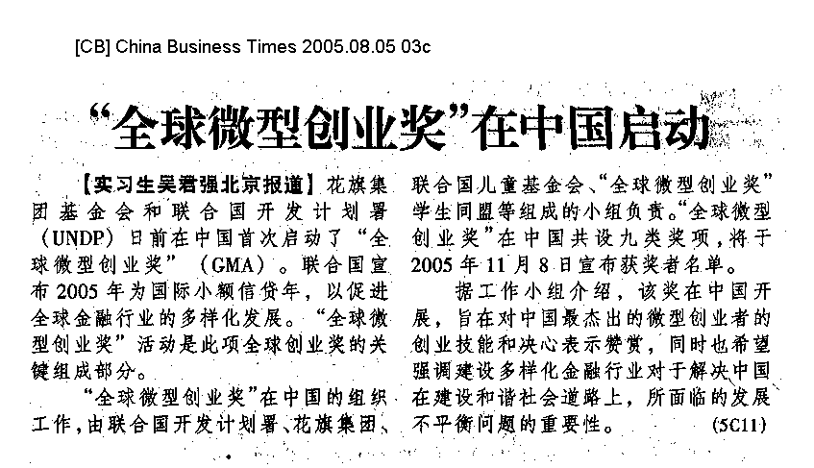

News Clipping from China top

Headline: Interview with Mr. Renaud Meyer, UNDP deputy resident representative 小额信贷：精彩不只２００５
——访联合国开发计划署驻华代表处副代表麦瑞德
Publication: China Cooperation Times 中华合作时报
Paper Date: 2005.08.05
Page: http://www.zh-hz.com/news/index.asp?newsid=5313&weekly=合作金融
Journalist(s): n/a
________________________________________________________________________________________
Summary: Citigroup Foundation and The United Nations Development Programme ("UNDP") launches the first-ever Global Microentrepreneurship Awards ("GMA") in China to recognize and support the entrepreneurial skills and resolve of some of the country's most outstanding microentrepreneurs. Mr. Renaud Meyer, UNDP deputy resident representative, receives an interview concerning the GMA program.

小额信贷：精彩不只２００５
——访联合国开发计划署驻华代表处副代表麦瑞德
添加时间：2005-08-05 11:00:24
"2005全球微型创业奖"评选活动是国际小额信贷年的标志性活动
新闻背景
２００５全球微型创业奖启动
本报讯 (记者 刘小萃) 日前，花旗集团基金会和联合国开发计划署（ＵＮＤＰ）在中国首次启动了“全球微型创业奖”（ＧＭＡ），旨在对中国最杰出的微型创业者的创业技能和决心表示认可和赞赏。其目的就是要奖励那些通过艰苦努力改变自身生活、家庭环境及社区的成功小额信贷客户和从事小额信贷工作的优秀信贷员。“全球微型创业奖”在中国的开展，尤其希望强调建设多样化金融行业对于解决中国在建设和谐社会道路上所面临的发展不平衡问题的重要性。
“全球微型创业奖”在中国的组织工作，由联合国开发计划署、花旗集团、联合国儿童基金会、“全球微型创业奖”学生同盟和小额信贷促进网络组成的工作小组负责。

“兼容并蓄、包罗万象”是记者在采访联合国开发计划署驻华代表处副代表麦瑞德时听到最多的词汇，这是他对未来中国金融体系发展趋势非常形象的描绘。无疑，小额信贷正在为实现“兼容并蓄、包罗万象的金融体系”发挥着日益重要的作用。
十年耕耘
联合国将２００５年确定为“国际小额信贷年”，其目的是提高公众对小额信贷重要性的认识并建立包括金融行业在内的联盟，共同战胜贫困。麦瑞德告诉记者， ２００５年对于中国小额信贷的发展意义非凡，但小额信贷所做出的卓越贡献却早在１０年前就已经开始了，其影响力还将不断延续下去。
“联合国开发计划署开始在中国发展小额信贷是在１９９４年。” 麦瑞德告诉记者，当时他们是与中国国际经济技术交流中心合作，由其提供支持和协调，项目首先在云南建立了基层农村发展协会，后来逐渐发展到了１６个省区的４８个村。项目总投入接近２０００万美元，其中一半被投入到一个自动展期贷款基金中，项目至今已向中国各地超过３０万客户发放了小额贷款。
“培训、参与和赋权是联合国开发计划署小额信贷项目的核心。” 麦瑞德表示，除了发放贷款，联合国开发计划署还支持能力发展项目，旨在为贷款者提供工作和生活的技巧，使他们了解贷款所具有的潜在作用。由于核心战略清晰，通过成功定位于最贫困的人群，项目最终取得了良好的贷款回收率，展示了小额贷款在中国成为能够有效减少贫困的方式的巨大潜力。
“到了２００１年，中国小额信贷工作出现了质的突破。” 麦瑞德告诉记者，那一年，联合国开发计划署与中国国际经济技术交流中心启动了可持续小额信贷扶贫项目，集中４个试点村，帮助农村发展协会实现可持续性。其中３个村在运作上实现了可持续性，还有一个村参加了全球性的由名为“助贫咨询组”的机构组织的“财务透明奖”。根据试点经验以及国际和国内最好的做法，项目还编写了一套管理手册。
战略转移
当谈到下一步的发展计划时，麦瑞德向记者做了一个假设：“也许有一天你会发现，世界性的援助机构对中国小额信贷的投入会慢慢减少，千万不要以为这是坏事情，他们是在进行更重要的工作，从‘单纯的资金投入’向‘运作小额信贷先进经验的传播’方向转移，后者的意义将更为重大而持久。”
“基于十多年的实践经验，联合国开发计划署正将其工作重点转移到政策层面。”麦瑞德认为，阻碍小额信贷在中国发展的三个相互关联的不足之处是：政策法律环境、可持续发展能力和资金问题。目前，联合国开发计划署已把工作重点从资金问题转移到致力于解决前两个问题。
联合国开发计划署与中国人民银行合作，于今年出版了一份全面考察中国小额信贷和项目经验的政策研究报告，为中国针对私人小额信贷业务的法律政策框架的建立提供了政策建议。
此框架的关键组成部分之一是建立中国小额信贷协会，联合国开发计划署将支持其组织构建和能力建设。协会主要职能是成为中国所有小额信贷机构的行业组织，协会将为小额信贷机构提供培训、技术扶持、信息分享、自我管理及集资，帮助在全国范围内建立充满活力的小额信贷部门。
迎接挑战
２００１年，中国加入世界贸易组织，带来了金融体系的大胆改革。这场预计于２００７年完成的重要转变不仅正在对中国的经济和国内国际各方面发展产生深远的影响，同时这种影响也波及到了贫困和弱势群体。
“我们面临的挑战是如何把贫困和弱势群体的需求融入到常规金融服务中，为他们提供机会，而不是慈善捐助。” 麦瑞德表示，建立综合的金融体系将会释放低收入者努力改善生活和脱离贫困的潜能，使之成为减贫和实现千年发展目标的强有力工具。
“联合国开发计划署正与多个伙伴一起从多个方面推动小额信贷的发展。首先是建立一个清晰的、规范小额信贷机构建立和运作的法律框架，以及创建一个由参与者建立并为参与者服务的协会，能够促进中国基层小额信贷部门的发展。同时，充分挖掘广大未开发市场的商业潜力，以促使传统金融企业发展他们的下游网络。”麦瑞德认为，这两个因素互相促进，将会催生一个多面的小额信贷部门，它能够服务于大多数的低收入者，根据不同的需求提供多样化的金融产品。
“如果一些小额信贷机构实现了可持续发展，并且业绩优良，未来它们就有可能成为真正的银行。”在谈到未来中国小额信贷发展远景时，麦瑞德表示了极大的信心。中央一号文件已经明确指出要积极探索建立小额信贷组织，“自然人或企业”也可以发起成立小额信贷组织，麦瑞德认为，这些“自然人或企业”将成为示范意义极强的先驱，而目前央行和银监会正在协同制订促进小额信贷发展的具体管理办法和试点方案，也必将对推动小额信贷的发展起到重要作用。

News Clipping from China top

Headline: Interview with Renaud Meyer, UNDP deputy resident representative 小额信贷：精彩不只2005
Publication: China Cooperation Times 中华合作时报
Paper Date: 2005.08.05
Page: 01
Journalist(s): Liu Xiaocui
________________________________________________________________________________________
Summary: Citigroup Foundation and The United Nations Development Programme ("UNDP") launches the first-ever Global Microentrepreneurship Awards ("GMA") in China to recognize and support the entrepreneurial skills and resolve of some of the country's most outstanding microentrepreneurs. Mr. Renaud Meyer, UNDP deputy resident representative, is interviewed concerning the GMA program.

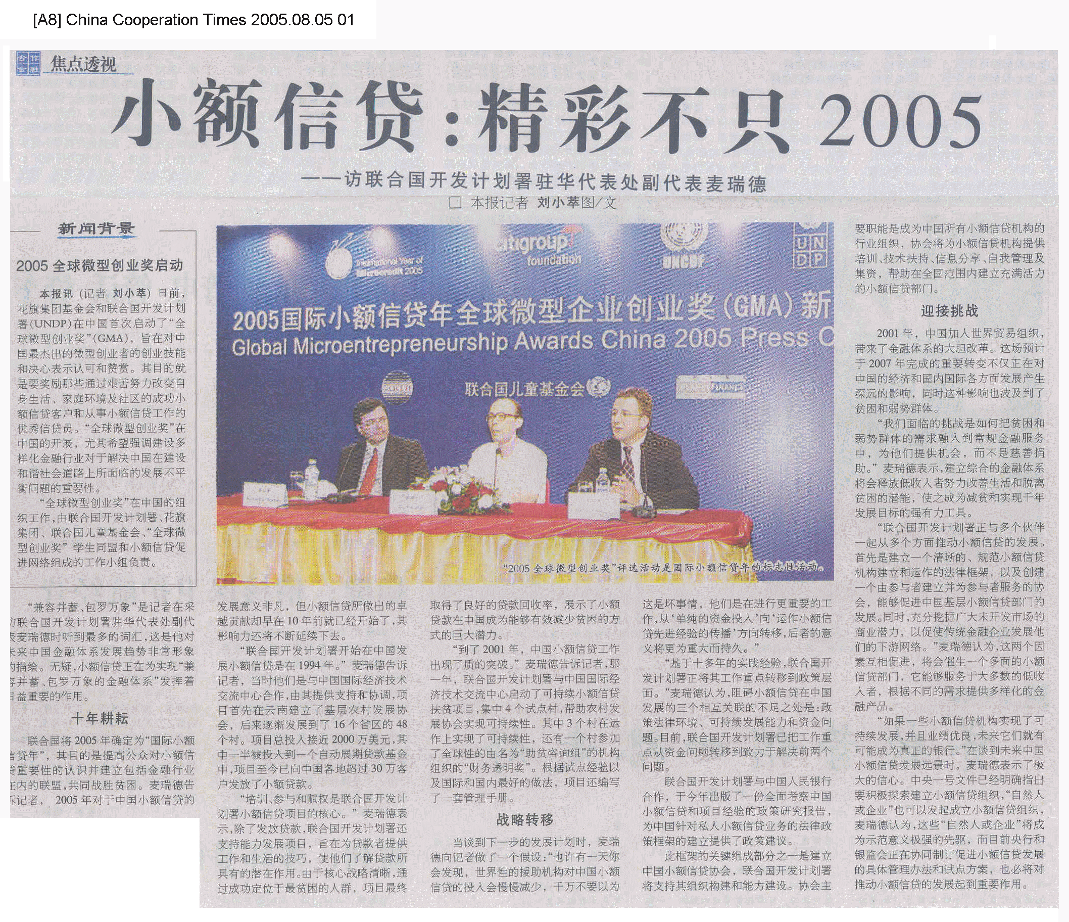

News Clipping from China top

Headline: Global Microentrepreneurship Awards start in China 中国首次启动全球微型创业奖
Publication: Dalian Evening News 大连晚报
Paper Date: 2005.08.05
Page: c01b
Journalist(s): n/a
________________________________________________________________________________________
Summary: Aug.3, Citigroup Foundation and The United Nations Development Programme ("UNDP") launch the first-ever Global Microentrepreneurship Awards ("GMA") in China. Awards will be presented in nine categories, with the winners announced on Nov. 8, 2005.

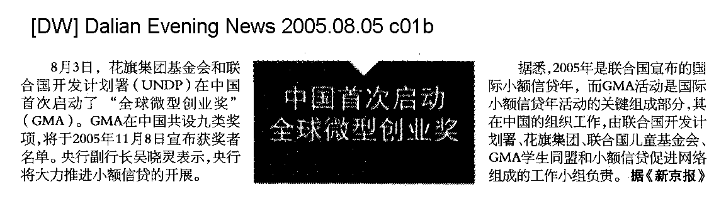

News Clipping from China top

Headline: Citigroup Foundation and UNDP launch Global Microentrepreneurship Awards in China 联合国开发计划署与花旗启动“全球微型创业奖”
Publication: www.chinanews.com.cn 中国新闻网
Paper Date: 2005.08.05
Page: http://www.chinanews.com.cn/news/2005/2005-08-05/26/608288.shtml
Journalist(s): Pan Xulin
________________________________________________________________________________________
Summary: Aug. 4 [sic: Aug. 3], Citigroup Foundation and The United Nations Development Programme ("UNDP") today launched the first-ever Global Microentrepreneurship Awards ("GMA") in China to recognize and support the entrepreneurial skills and resolve of some of the country's most outstanding microentrepreneurs. The United Nations has declared 2005 the International Year of Microcredit in an effort to promote more inclusive financial sectors around the globe. The GMA initiative is a key element of this worldwide undertaking.

联合国开发计划署与花旗启动“全球微型创业奖”
2005年08月05日 潘旭临

中新社北京八月四日电(记者潘旭临)联合国开发计划署与美国花旗集团基金会今天在北京首次启动“全球微型创业奖”，旨在对中国最杰出微型创业者的创业技能和决心表示认可和赞赏。
联合国宣布今年是国际小额信贷年，以促进全球金融行业的多样化发展，“全球微型创业奖”活动是此项全球事业的关键组成部分。
据了解，“全球微型创业奖”在中国的组织工作，由联合国开发计划署、花旗集团、联合国儿童基金会、“全球微型创业奖”学生同盟和小额信贷促进网络组成的工作小组负责。创业奖计划由联合国开发计划署与花旗集团的慈善分支机构——花旗集团基金会提供支持。由花旗集团基金会提供专款将用于“全球微型创业奖”计划的实施和奖金的发放。
“全球微型创业奖”在中国共分为乡村种植业、乡村养殖业、乡村非农业、城市贸易、城市加工业、城市服务业、以及一个特殊奖项：最具创意微型创业者奖等九类奖项。符合基本参赛条件的参赛者将进行角逐。评选委员会由多位在中国小额贷款领域具备丰富经验的人士组成，获奖者名单于十一月八日宣布。

News Clipping from China top

Headline: Encouraging transition from relief-oriented to development-oriented poverty programs 鼓励扶贫由“救济式”向“开发式”转变
Publication: China Economic Herald 中国经济导报
Paper Date: 2005.08.06
Page: a04a
Journalist(s): Yang Chuanmei
________________________________________________________________________________________
Summary: Aug. 4 [sic: Aug. 3], Citigroup Foundation and The United Nations Development Programme ("UNDP") launches the first-ever Global Microentrepreneurship Awards ("GMA") in China to recognize and support the entrepreneurial skills and resolve of some of the country's most outstanding microentrepreneurs. The United Nations has declared 2005 the International Year of Microcredit. The GMA initiative is a key element of this worldwide undertaking.

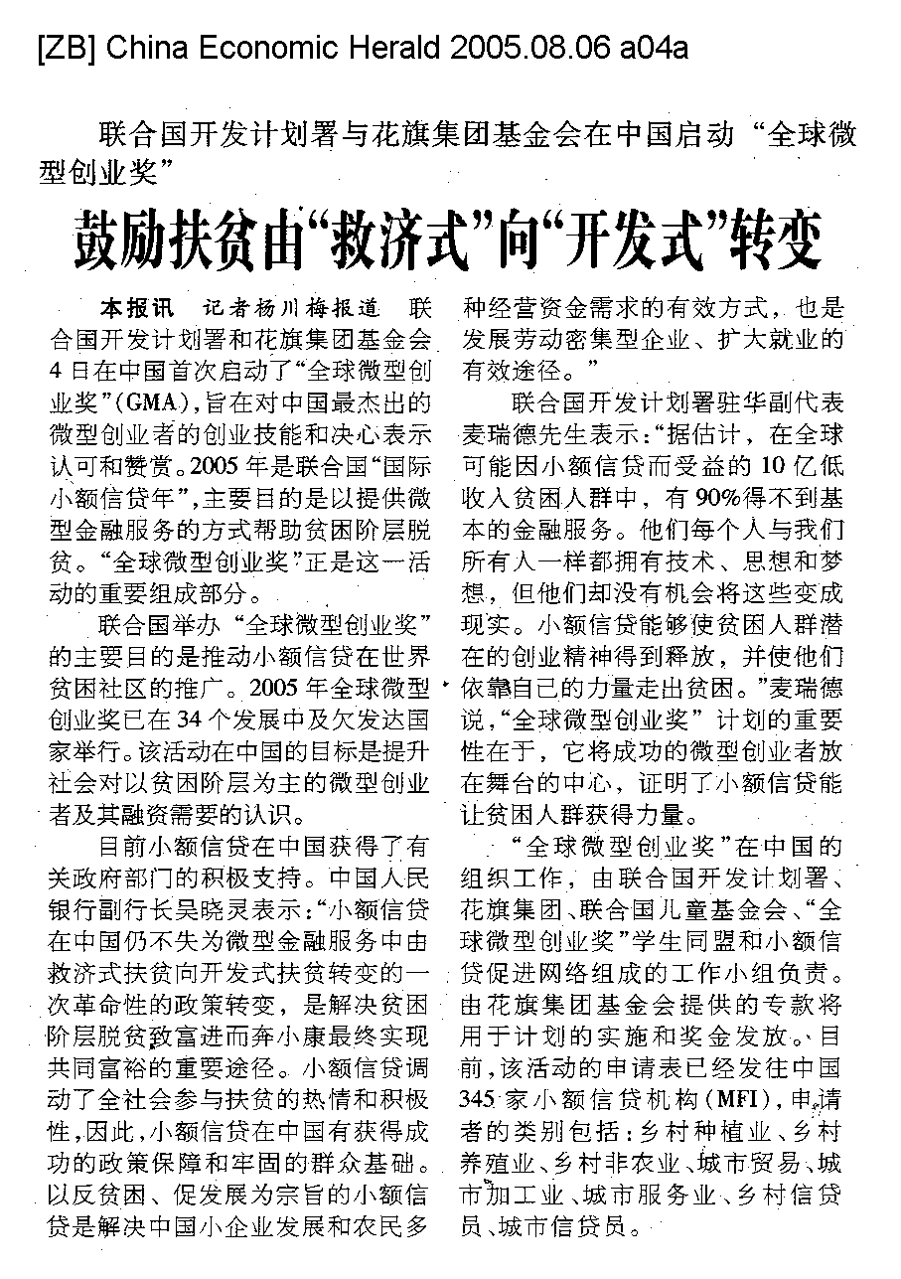

News Clipping from China top

Headline: Global Microentrepreneurship Awards start in China “全球微型企业奖”在中国启动
Publication: Securities Daily 证券日报
Paper Date: 2005.08.07
Page: a01
Journalist(s): Jie Jing
________________________________________________________________________________________
Summary: Citigroup Foundation and The United Nations Development Programme ("UNDP") today launched the first-ever Global Microentrepreneurship Awards ("GMA") in China. The United Nations has declared 2005 the International Year of Microcredit in an effort to promote more inclusive financial sectors around the globe. The GMA initiative is a key element of this worldwide undertaking.

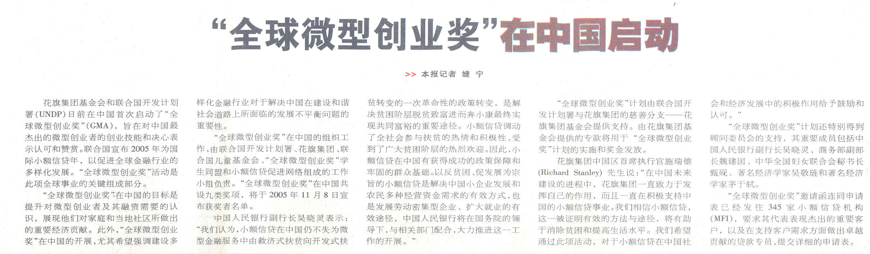

News Clipping from China top

Headline: Global Microentrepreneurship Awards launched in China “全球微型创业奖”在中国启动
Publication: Anhui Daily 安徽日报
Paper Date: 2005.08.08
Page: c01
Journalist(s): n/a
________________________________________________________________________________________
Summary: Aug.3, Richard Stanley, CEO of Citigroup China, holds a press conference to announce the commencement of Global Microentrepreneurship Awards ("GMA") in China. The GMA program is being supported by the Citigroup Foundation.

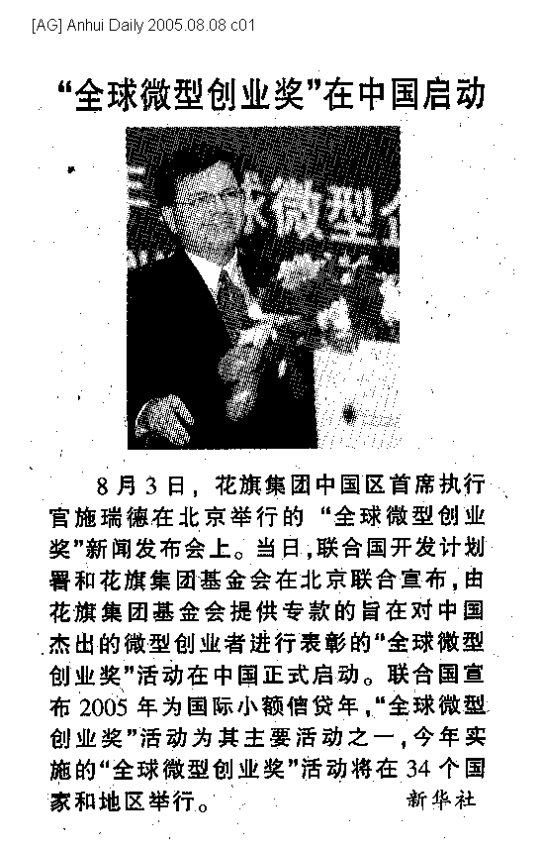

News Clipping from China top

Headline: Global Microentrepreneurship Awards start in China 中国首次启动全球微型创业奖
Publication: China Economic Weekly 中国经济周刊
Paper Date: 2005.08.08
Page: 55
Journalist(s): Deng Pengji
________________________________________________________________________________________
Summary: Aug.3, Citigroup Foundation and The United Nations Development Programme ("UNDP") launch the first-ever Global Microentrepreneurship Awards ("GMA") in China. Awards will be presented in nine categories, with the winners announced on Nov. 8, 2005. The United Nations has declared 2005 the International Year of Microcredit. The GMA initiative is a key element of this worldwide undertaking. In China, the GMA is facilitated by a multi-member team consisting of UNDP, Citigroup, UNICEF, the GMA Student Alliance, and the Microfinance Promotion Network.

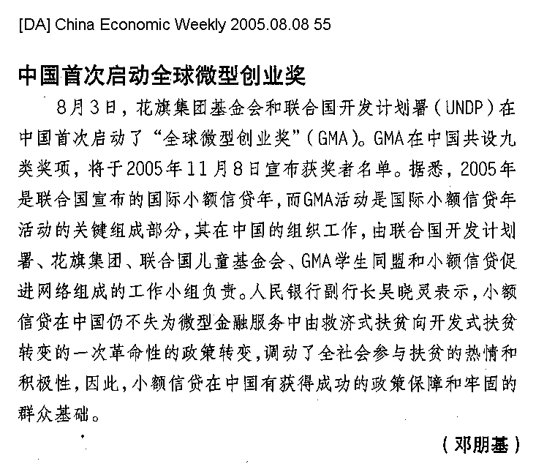

News Clipping from China top

Headline: Global Microentrepreneurship Awards start in China “全球微型企业创业奖”在中国启动
Publication: The First 竞报
Paper Date: 2005.08.08
Page: http://www.thefirst.cn/article.jsp?oid=6045831
Journalist(s): n/a
________________________________________________________________________________________
Summary: Aug. 3, Citigroup Foundation and The United Nations Development Programme ("UNDP") today launched the first-ever Global Microentrepreneurship Awards ("GMA") in China. The United Nations has declared 2005 the International Year of Microcredit in an effort to promote more inclusive financial sectors around the globe. The GMA initiative is a key element of this worldwide undertaking.

“全球微型企业创业奖”在中国启动
2005年08月08日
本报讯 近日，联合国开发计划署与花旗集团基金会在中国首次启动了“全球微型企业奖”项目。联合国宣布2005年为国际小额信贷年，以促进全球金融行业的多样化发展。“全球微型创业奖”活动是此项全球事业的关键组成部分。
该项目在中国共设九类奖项，由专门组成的评审委员会对中国345家小额信贷机构有杰出表现的客户和贷款专员进行评审，评审结果将在今年11月8日公布。
“全球微型创业奖”在中国的目标是提升对微型创业者及其融资需要的认识，奖励他们对家庭和当地社区所做出的经济贡献。今年是联合国指定的国际小额信贷年，“全球微型创业奖”是此项全球事业的关键组成部分，该项目将在中国、印度、俄罗斯、巴西等34个国家举行。

News Clipping from China top

Headline: UNDP and Citigroup Foundation launch Global Microentrepreneurship Awards in China 联合国开发计划署与花旗集团基金会在中国启动“全球微型创业奖”
Publication: www.china.com 中华网
Paper Date: 2005.08.08
Page: http://www.china.org.cn/chinese/jingji/932137.htm
Journalist(s): n/a
________________________________________________________________________________________
Summary: Aug. 3, Citigroup Foundation and The United Nations Development Programme ("UNDP") today launched the first-ever Global Microentrepreneurship Awards (GMA") in China to recognize and support the entrepreneurial skills and resolve of some of the country's most outstanding microentrepreneurs. The United Nations has declared 2005 the International Year of Microcredit in an effort to promote more inclusive financial sectors around the globe. The GMA initiative is a key element of this worldwide undertaking. Mr. Richard Stanley, CEO of Citigroup China, noted, "Citigroup is strongly committed to playing a role in China's future, and actively supports microfinance in China, which we believe is of proven value in the fight to eradicate poverty and raise living standards. We are committed to encouraging and recognizing the role of microfinance in China's ongoing social and economic development through this awards program."

联合国开发计划署与花旗集团基金会在中国启动“全球微型创业奖”
2005 年08 月04 日

北京8月3日电 花旗集团基金会和联合国开发计划署 (UNDP) 今天在中国首次启动了“全球微型创业奖”(GMA)，旨在对中国最杰出的微型创业者的创业技能和决心表示认可和赞赏。联合国宣布2005年为国际小额信贷年，以促进全球金融行业的多样化发展。“全球微型创业奖”活动是此项全球事业的关键组成部分。
“全球微型创业奖”在中国的目标是提升对微型创业者及其融资需要的认识，展现他们对家庭和当地社区所做出的重要经济贡献。此外，“全球微型创业奖”在中国的开展，尤其希望强调建设多样化金融行业对于解决中国在建设和谐社会道路上所面临的发展不平衡问题的重要性。
“全球微型创业奖”在中国的组织工作，由联合国开发计划署、花旗集团、联合国儿童基金会、“全球微型创业奖”学生同盟和小额信贷促进网络组成的工作小组负责。“全球微型创业奖”在中国共设九类奖项，将于2005年11月8日宣布获奖者名单。
中国人民银行副行长吴晓灵表示：“我们认为，小额信贷在中国仍不失为微型金融服务中由救济式扶贫向开发式扶贫转变的一次革命性的政策转变，是解决贫困阶层脱贫致富进而奔小康最终实现共同富裕的重要途径。小额信贷调动了全社会参与扶贫的热情和积极性，受到了广大贫困阶层的热烈欢迎。因此，小额信贷在中国有获得成功的政策保障和牢固的群众基础。以反贫困、促发展为宗旨的小额信贷是解决中国小企业发展和农民多种经营资金需求的有效方式，也是发展劳动密集型企业、扩大就业的有效途径，中国人民银行将在国务院的领导下，与相关部门配合，大力推进这一工作的开展。”
“全球微型创业奖”计划由联合国开发计划署与花旗集团的慈善分支 -- 花旗集团基金会提供支持。由花旗集团基金会提供的专款将用于“全球微型创业奖”计划的实施和奖金发放。
花旗集团中国区首席执行官施瑞德 (Richard Stanley) 先生说：“在中国未来建设的进程中，花旗集团一直致力于发挥自己的作用，而且一直在积极支持中国的小额信贷事业。我们相信小额信贷，这一被证明有效的方法与途径，将有助于消除贫困和提高生活水平。我们希望通过此项活动，对于小额信贷在中国社会和经济发展中的积极作用给予鼓励和认可。”
“全球微型创业奖”计划还特别得到顾问委员会的支持，其重要成员包括中国人民银行副行长吴晓灵、商务部副部长魏建国、中华全国妇女联合会秘书长甄砚、著名经济学家吴敬琏和著名经济学家茅于轼。
“全球微型创业奖”邀请函连同申请表已经发往345家小额信贷机构 (MFI)，要求其代表表现杰出的重要客户，以及在支持客户需求方面做出卓越贡献的贷款专员，提交详细的申请表。
符合基本参赛条件的参赛者将分九大类别进行角逐：乡村种植业、乡村养殖业、乡村非农业、城市贸易、城市加工业、城市服务业、乡村信贷员、城市信贷员，以及一个特殊奖项：最具创意微型创业者奖。
几轮筛选过后，最终获奖者将由评选委员会选出。评选委员会由多位在中国小额信贷领域具备丰富经验的重要人士组成，其中包括中国人民银行金融监管部主管徐忠、国务院扶贫办公室政策研究所研究员苏国霞、中华全国妇女联合会妇女发展部主任崔玉、中国人民大学农业与农村发展学院教授温铁军、亚洲发展银行驻华代表汤敏、福特基金会中国办事处代表 Andrew Watson 和花旗集团中国区国家风险经理林铭恩女士。
联合国开发计划署驻华副代表麦瑞德 (Renaud Meyer) 先生说：“据估计，在可能因小额信贷而受益的10亿低收入贫困人群中，有90%得不到基本的金融服务。他们每个人与我们所有人一样都拥有技术、思想和梦想，但他们却没有机会将这些变成现实。小额信贷能有如此巨大的力量，正是由于它能够使贫困人群潜在的创业精神得到释放，并使他们依靠自己的力量走出贫困。“全球微型创业奖”计划的重要性在于，它将成功的微型创业者放在舞台的中心，使他们证明小额信贷如何能让贫困人群获得力量，并发挥全世界贫困地区存在的创业精神。”
联合国开发计划署简介
联合国开发计划署是联合国从事发展的机构。我们注重消除贫困，倡导变革，为各国提供知识、经验和资源，以帮助人们建设美好的生活。我们帮助发展中国家吸引和有效地使用国际援助，致力于在全世界实现可持续发展。联合国开发计划署跟踪、统计各国实现千年发展目标的状况，连接和协调全球以及各国为实现这些目标而做出的努力。
花旗集团简介
花旗在中国的历史可追溯至1902年5月。如今，花旗已是中国顶尖外资银行，为客户提供最广泛的金融产品。目前，花旗在北京、上海、广州、深圳和天津设立5家企业与投资银行分行；同时有9家个人零售银行营业网点；在厦门和成都建立代表处；中国区总部也设在上海浦东。作为花旗集团在全球100多个国家网络的一部分，花旗银行已成为在中国最具全球性的外资银行。

News Clipping from China top

Headline: Microfinance helps China's poverty alleviation and development program 小额信贷助力中国扶贫开发
Publication: China Environmental News 中国环境报
Paper Date: 2005.08.09
Page: 04a
Journalist(s): Huang Yong
________________________________________________________________________________________
Summary: Aug. 3, Citigroup Foundation and The United Nations Development Programme ("UNDP") today launched the first-ever Global Microentrepreneurship Awards ("GMA") in China to recognize and support the entrepreneurial skills and resolve of some of the country's most outstanding microentrepreneurs. The United Nations has declared 2005 the International Year of Microcredit in an effort to promote more inclusive financial sectors around the globe. The GMA initiative is a key element of this worldwide undertaking. Mr. Richard Stanley, CEO of Citigroup China, says that microfinance is of proven value in the fight to eradicate poverty and raise living standards.

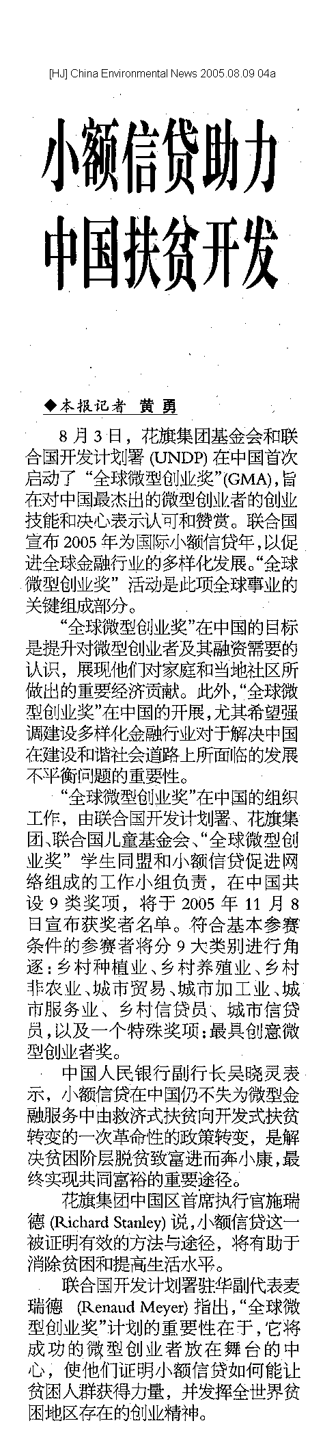

News Clipping from China top

Headline: Global Microentrepreneurship Awards launched in China for the first time “全球微型创业奖”首次在华启动
Publication: China Youth Daily 中国青年报
Paper Date: 2005.08.09
Page: 10
Journalist(s): Wang Chong
________________________________________________________________________________________
Summary: Aug. 3, Citigroup Foundation and The United Nations Development Programme ("UNDP") today launched the first-ever Global Microentrepreneurship Awards (GMA") in China to recognize and support the entrepreneurial skills and resolve of some of the country's most outstanding microentrepreneurs. The United Nations has declared 2005 the International Year of Microcredit in an effort to promote more inclusive financial sectors around the globe. The GMA initiative is a key element of this worldwide undertaking.

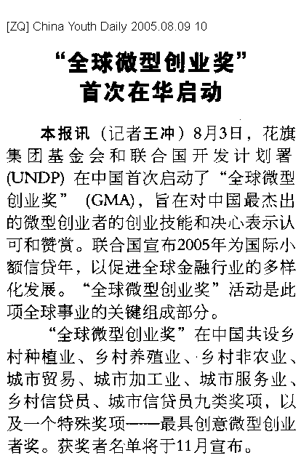

News Clipping from China top

Headline: Global Microentrepreneurship Awards launched in China for the first time “全球微型创业奖”首次在华启动
Publication: China Youth Daily 中国青年报
Paper Date: 2005.08.09
Page: http://zqb.cyol.com/gb/zqb/2005-08/09/content_43966.htm
Journalist(s): Wang Chong
________________________________________________________________________________________
Summary: Aug. 3, Citigroup Foundation and The United Nations Development Programme ("UNDP") today launched the first-ever Global Microentrepreneurship Awards ("GMA") in China to recognize and support the entrepreneurial skills and resolve of some of the country's most outstanding microentrepreneurs. The United Nations has declared 2005 the International Year of Microcredit in an effort to promote more inclusive financial sectors around the globe. The GMA initiative is a key element of this worldwide undertaking.

“全球微型创业奖”首次在华启动
2005年08月09日
本报讯（记者王冲）8月3日，花旗集团基金会和联合国开发计划署（UNDP）在中国首次启动了“全球微型创业奖”（GMA），旨在对中国最杰出的微型创业者的创业技能和决心表示认可和赞赏。联合国宣布2005年为国际小额信贷年，以促进全球金融行业的多样化发展。“全球微型创业奖”活动是此项全球事业的关键组成部分。
“全球微型创业奖”在中国共设乡村种植业、乡村养殖业、乡村非农业、城市贸易、城市加工业、城市服务业、乡村信贷员、城市信贷员九类奖项，以及一个特殊奖项———最具创意微型创业者奖。获奖者名单将于11月宣布。

News Clipping from China top

Headline: Citigroup launches Global Microentrepreneurship Awards 花旗集团设全球策型创业奖
Publication: Economic Daily 经济日报
Paper Date: 2005.08.09
Page: 07a
Journalist(s): Jin Kai
________________________________________________________________________________________
Summary: Citigroup Foundation and The United Nations Development Programme ("UNDP") yesterday (Aug.3) launched the first-ever Global Microentrepreneurship Awards ("GMA") in China to recognize and support the entrepreneurial skills and resolve of some of the country's most outstanding microentrepreneurs.

