Financial Diaries Project – Mimimi and Jonas
2nd Installment

January 7, 2004

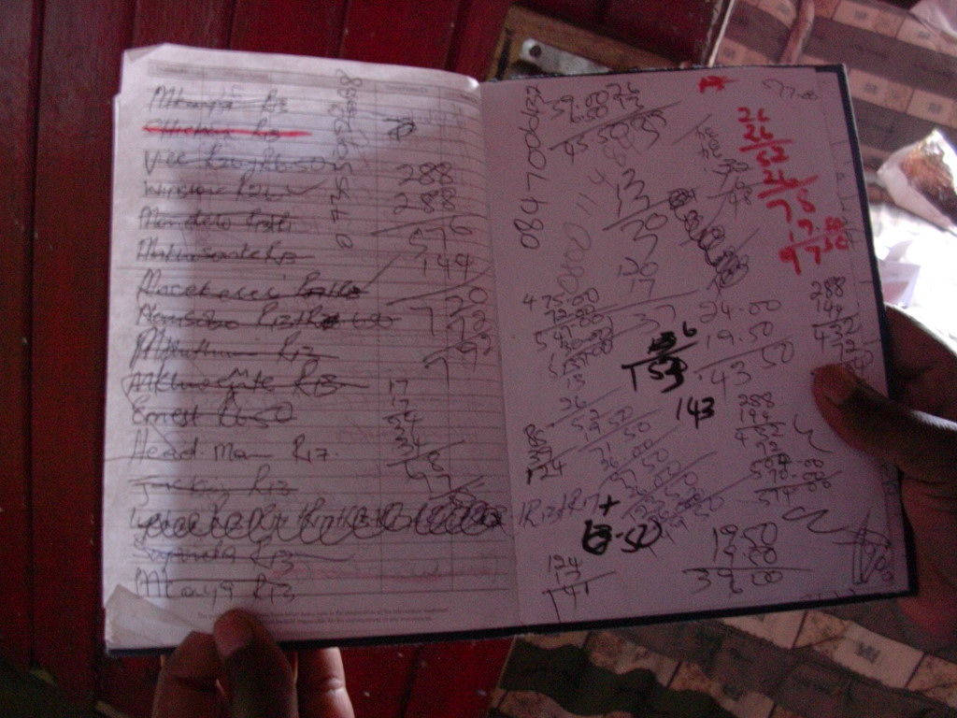
Fresh from the year-end holiday, we met Mimimi back at the shabeen for our second interview. She’s just come back from visiting her parents outside Queenstown and Jonas’ parents in Idutuywa, about 15 hours drive from Cape Town. They spent most of their time with Jonas’ family, because, we learned, they are building a house nearby! Mimimi is full of life describing this home that she and Jonas are building. We’re a bit confused – if she is building such a beautiful house in the Eastern Cape, does that mean that they’ll be returning soon? Not at all, she replies. Cape Town is good for working, but you must have a family home near your relatives – to hold family feasts, to retire to and to be buried from. If you have a family of your own, you can’t be buried from your parents’ home - they must take the coffin from your own home.
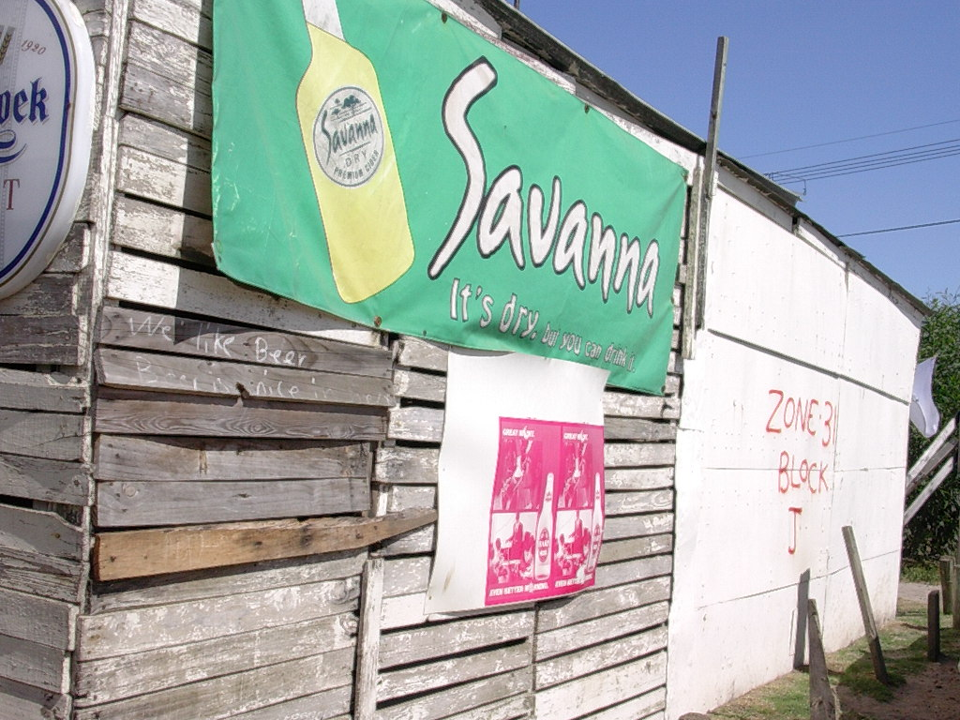
As we discussed this further, we learned that the house was not the only asset that Mimimi and Jonas left at home, they also had quite a bit of livestock. They had one cow, four goats, one pig and ten chicken. When we took stock of these assets and the physical assets in the Cape Town shack, it added up to a substantial amount:

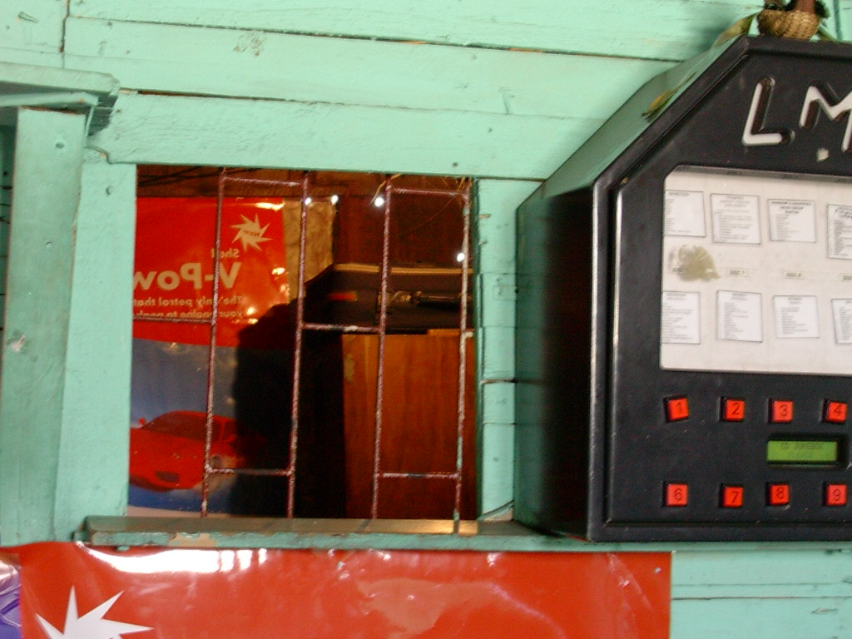
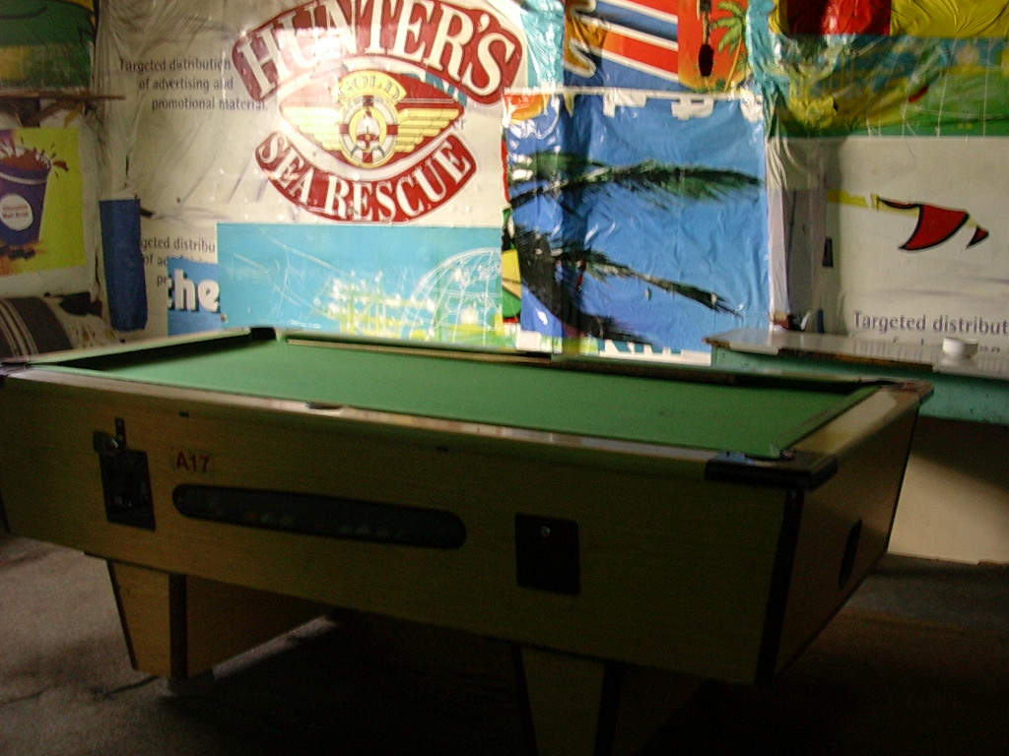
We were surprised to see that this shack-dwelling couple, who we first would have expected to have nothing, actually had quite a bit. How did they manage to accumulate some $2500 worth of assets? As we discussed each item, it seems that the cow and the goats were an inheritance from Jonas’ family, although the pig and the chickens were bought in the last year or two. In Cape Town, most of the assets were accumulated in the past four years. The larger furniture and appliances was accumulated by using a credit account at the retail store where it was bought. The shack was built by Jonas when he first came to the Joe Slovo settlement many years ago, using money he was earning from his job along with money he had been earning with his spaza shop business. The smaller items in the shack were bought using cash, which had been saved up in Jonas’ bank account.

As we discussed the house in the Eastern Cape further, we learned that quite a bit of money had been left behind to continue building the house after the holiday period. Mimimi explained that they left money for cement for the floors and more money to buy doors for the house. When we added up all the expenses, the total was about R1600 (about $260), quite a bit of money. She laughed at us and said that the money for the house was a drop in the bucket – they had brought a total of R4500 (about $750) to the Eastern Cape, to pay not only for the house but also for Christmas! Beside the R1600 they spent on the house, they spent about R880 ($150) on the bus to travel to and from the Eastern Cape, gave a R200 gift to Jonas’ mother and the remaining R1820 ($300) was spent on the Christmas feast and clothes for their three children that live with Jonas’ mother. We found this to be a very substantial Christmas, but Mimimi said it was very typical of how they spent the holiday.

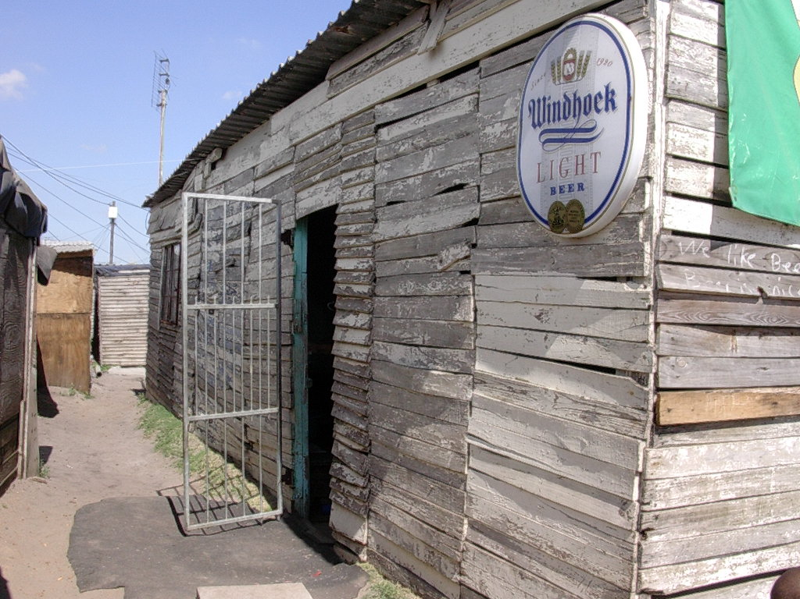
As we started to ask about where they had accumulated this surprising sum of money, Jonas walked in. We were surprised – we thought he had been at work! No, he explained, very upset, he had lost his job. He had been working for a gardening company and a company based in the nearby suburb of Newlands had taken over the contract he had been working on. He had no formal contract with the gardening company and had only been working for them since October. He was very upset because it was a well paid job. He received a gross wage of R1700 per month (about R280). Each month UIF of R17 was deducted. This is a deduction for the Unemployment Insurance Fund, from which Jonas is able to claim if he loses his job. A net wage of R1683 is then deposited into his bank account every month. This is the most amount of money he had ever earned and he was very concerned about losing this job. We asked whether he would claim from the Unemployment Insurance Fund, but he wasn’t entirely sure whether he was able and he had no idea how he would go about it. He didn’t seem to pay much attention to this idea – he was more fixated on finding a new job.

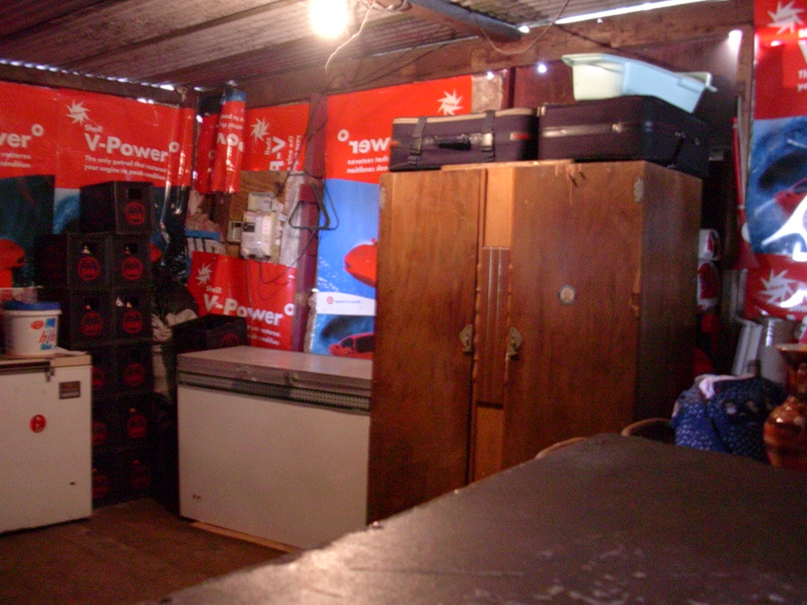
With this shocking discovery so fresh in their lives, we thought it appropriate for us to leave, even though there were so many unanswered questions in our minds. How would Jonas find another job? If he was earning only $280 per month, how did they ever manage to accumulate $750 to bring to the Eastern Cape? We did the math in our minds – we thought for sure that Mimimi didn’t make more than $200 per month with the shabeen business. Did they save it in Jonas’ bank account? More questions to ask next time we came.
