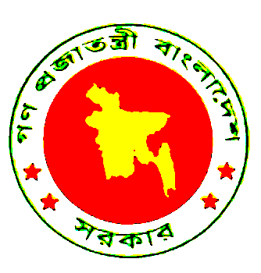 | BANGLADESH

As delivered

Statement by
H.E. Dr. Iftekhar Ahmed Chowdhury
Ambassador and Permanent Representative of Bangladesh to the United Nations
at the UN International Forum to Build Inclusive Financial Sector
International Year of Microcredit 2005
New York, 08 November 2005

Mr. Chairman
Distinguished delegates
Ladies and Gentlemen,

Even at the risk of eroding my three-minute limit somewhat, it would be remiss of me to begin without thanking Dr. Fischer for his kind sentiments expressed with regard to Bangladesh, my predecessor and myself. Friends and beneficiaries of microcredit everywhere owe him a deep gratitude for his continuing contributions to this cause.

Mr. Chairman,

Bangladesh’s progress in recent times with regard to her development achievements has provoked considerable global interest. This success is perceived as being owed to, among others, home grown ideas like microcredit. These are products of our indigenous intellectual and cultural resources. Bangladeshis should be forgiven for the modicum of pride they must feel that their country should be considered a thought-leader in this respect, and as a principal propagator of an idea that in many parts of the world is viewed as a major instrument of poverty alleviation. This is also evidence of the fact that simplest of concepts can effect the profoundest of changes.

Micro-credit has helped convince the world that the poor are innately capable of working their way out of its morass with dignity. Also, that they have the creativity and capacity to improve their own situation. The contribution of microfinance to asset-creation, to employment generation, to providing economic security, and to the empowerment of the poor, particularly women, is widely acknowledged. Micro-credit is also seen as one of those instruments that, by stabilizing conflict-ridden societies, would help drain the marshes that produce thoughts and acts of terrorism. As we become increasingly engaged with peace-building responsibilities in strife-torn parts of the world, microcredit can play a significant role in sustaining peace. The General Assembly, the Security Council, the recently held Gleneagles Summit, the international financial institutions, have all acknowledged the efficacy of microfinance as an effective anti-poverty tool. As is evident from news in the field from all parts of the world, it works, if, of course, the right wherewithal is provided!

We now need to provide that. It includes necessary legal, financial and social framework for microfinance to work effectively. We are pleased to note that the Forum focuses on building inclusive financial sector. We hope that ideas generated here will help facilitate the participation of the private sector to set up institutions to extend financial services to the so called ‘unbankable’ poor. However, we must ensure that these services reach the target group.

Credit may be the primary requirement of the poorest of the poor. But credit alone will not be sufficient to change their fate. Entrepreneurial trainings must accompany finance. This product should be packaged with basic knowledge of hygiene and health, social rights and responsibilities, and also with education to maximize its benefits. If done thus, microfinance can unleash the huge potentials of the poor be able to bring about a sea-change in their lives lifting them out of the clap-trap of poverty. Bangladeshi civil society and our NGOs such as Grameen Bank, BRAC and PKSF have played a yeoman’s role in this regard.

The momentum generated through the observance of the Year must be preserved and further enhanced. It is a categorical imperative for our Governments as well as the UN will to follow up on the progress to date. In microcredit we have an effective tool at hand. We must make proper use of it to supplement our efforts to rid our world of injustice, inequality and indignity that still sadly dot this globe.

I thank you.

