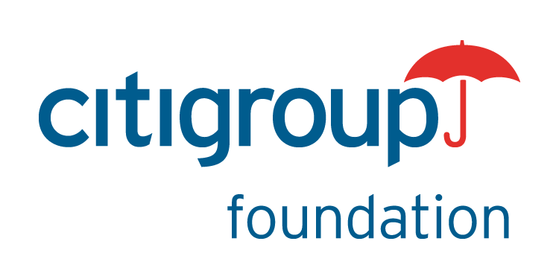
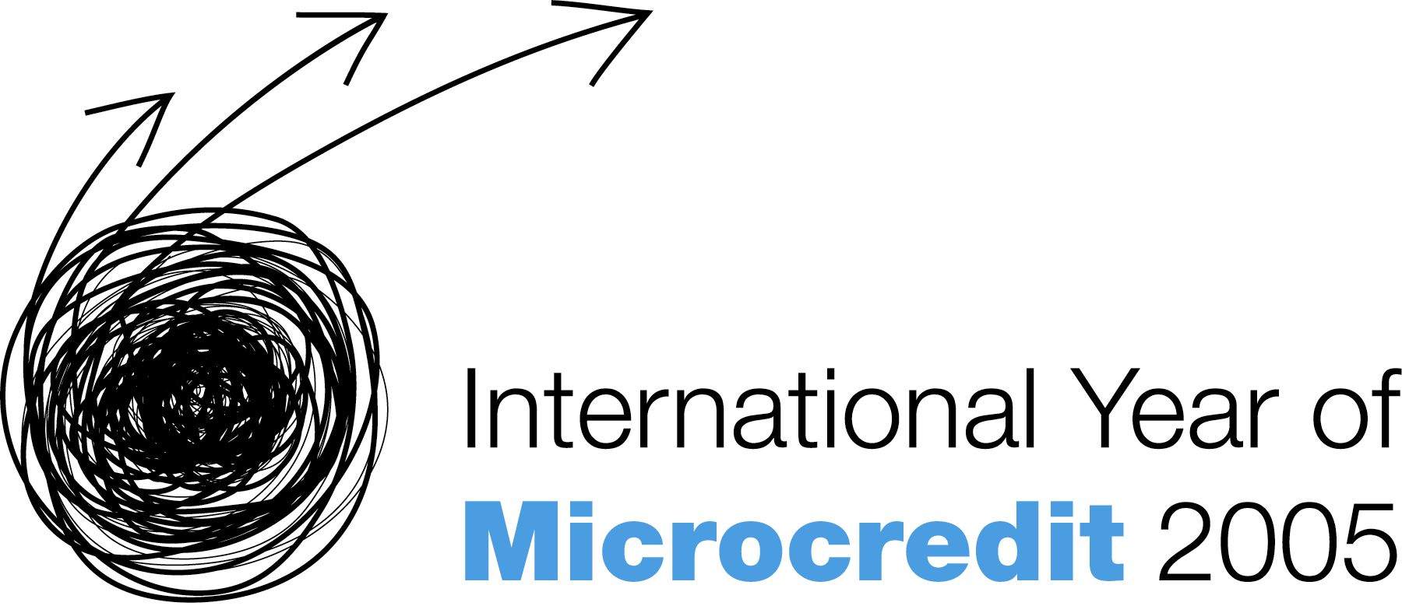
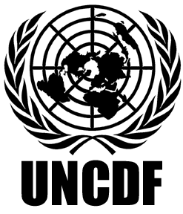
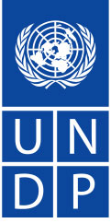

Citigroup Foundation and United Nations Development Programme Launch
Global Microentrepreneurship Awards in China

Beijing, August 3, 2005: Citigroup Foundation and The United Nations Development Programme (“UNDP”) today launched the first-ever Global Microentrepreneurship Awards (“GMA”) in China to recognize and support the entrepreneurial skills and resolve of some of the country’s most outstanding microentrepreneurs. The United Nations has declared 2005 the International Year of Microcredit in an effort to promote more inclusive financial sectors around the globe. The GMA initiative is a key element of this worldwide undertaking.

The goal of the Awards in China is to raise awareness of microentrepreneurs and their financial needs, and to demonstrate the significant economic contribution that they make to their families and local communities. In China the GMA also seeks to highlight the importance of building inclusive financial sectors as a part of efforts to address the development imbalances that China faces on the path towards building a harmonious society.

In China, the GMA is facilitated by a multi-member team consisting of UNDP, Citigroup, UNICEF, the GMA Student Alliance, and the Microfinance Promotion Network. Awards will be presented in nine categories, with the winners announced on November 8, 2005.

Madam Wu Xiaoling, Vice Governor of the People's Bank of China, stated that, “In our opinion, the introduction of microcredit schemes marks a revolutionary transformation of China’s poverty reduction policy from relying on relief support to that focusing on development, and serves as an important means of aiding vulnerable groups in society in their efforts to achieve prosperity. I am confident of the success of microcredit business in China as it enjoys both solid policy support from the government as well as wide participation throughout society."

The GMA Programme is being supported by the Citigroup Foundation, the philanthropic arm of Citigroup, and the UNDP. The grant from the Citigroup Foundation will be put towards the implementation of the GMA Programme as well as the prize money.

Mr. Richard Stanley, CEO of Citigroup China, noted, "Citigroup is strongly committed to playing a role in China’s future, and actively supports microfinance in China, which we believe is of proven value in the fight to eradicate poverty and raise living standards. We are committed to encouraging and recognizing the role of microfinance in China’s ongoing social and economic development through this Awards programme.”

The GMA Programme also has the privilege of being supported by an Advisory Council, whose distinguished members are: Mme Wu Xiaoling, Vice Governor of the People’s Bank of China; Mr. Wei Jianguo, Vice Minister of Ministry of Commerce; Ms. Zhen Yan, Secretary General of All-China Women’s Federation; and renowned economists Mr. Wu Jinglian and Mr. Mao Yushi.

Invitation letters to Microfinance Institutions with application forms have already been sent out to 345 individual microfinance institutions (MFIs), asking them to submit detailed applications on behalf of clients who have shown outstanding performance, as well as to those loan officers who have demonstrated dedication in supporting the needs of their clients.

Contestants who meet the basic entry requirements will compete in nine categories: Rural agriculture, Rural animal husbandry, Rural non-agricultural, Urban trade, Urban processing, Urban services, Urban loan officer, Rural loan officer, and a special prize: Most innovative microentrepreneur.

After several rounds of screening, the final winners will be selected by an Awards Selection Committee consisting of several experienced dignitaries in Chinese microcredit, including Mr. Xu Zhong, Chief, Financial Supervision Division of the People’s Bank of China, Ms. Su Guoxia, Research Fellow of Policy Research Institute of the State Council’s Poverty Alleviation Office, Ms. Cui Yu, Director General of Women’s Development Department of the All-China Women’s Federation, Mr. Wen Tiejun, Mr. Tang Min, Chief Reprehensive of Asia Development Bank, China, Professor of Agriculture and Rural Area Development School of Remin University, Mr. Andrew Watson, China Office representative of the Ford Foundation and Ms. Tammy Lam, Country Risk Manager, Citigroup China.

Mr. Renaud Meyer, UNDP Deputy Resident Representative said, “It is estimated that of the one billion poor and low-income people who could benefit from microfinance, 90% do not have access to basic financial services. Every one of these people possesses skills, ideas and dreams like us all, but they are denied the opportunities to put them into practice. Microcredit is so powerful precisely because it releases the untapped entrepreneurial spirit of the poor and permits them to use their skills to grow out of poverty. The importance of the GMA Programme is that it places successful microentrepreneurs on center stage and lets them illustrate how microfinance can empower the destitute and release the entrepreneurial spirit that already exists in impoverished communities worldwide.”

About UNDP
UNDP is the UN's global development network, advocating for change and connecting countries to knowledge, experience and resources to help people build a better life. We are on the ground in 166 countries, working with them on their own solutions to global and national development challenges.

UNDP is an advocate for nationally-owned solutions to reduce poverty through action rooted in strong partnerships and inclusive participation. It sponsors innovative pilot projects; supports poverty monitoring and analysis at the country level; provides policy advice; and it shares knowledge of good practices.

UNDP also connects countries to global knowledge networks and promotes equity and gender equality in the quest to alleviate poverty. It helps bring governments, civil society organizations, private sector representatives and outside partners together to achieve coordinated and effective responses to the poverty challenge.

About Citigroup
Citigroup (NYSE: C), the leading global financial services company has some 200 million customer accounts and does business in more than 100 countries, providing consumers, corporations, governments and institutions with a broad range of financial products and services, including consumer banking and credit, corporate and investment banking, securities brokerage, and wealth management. Major brand names under Citigroup's trademark red umbrella include Citibank, CitiFinancial, Primerica, Smith Barney and Banamex. Additional information may be found at www.citigroup.com

Citigroup first established an office in China in Shanghai in 1902. Today it has a network of five corporate and investment bank branches – Beijing, Shanghai, Guangzhou, Shenzhen and Tianjin, and nine consumer bank outlets – Beijing, Shanghai, Guangzhou, Shenzhen and Tianjin, two representative offices in Xiamen and Chengdu. Additional information may be found at www.citibank.com.cn

Media contact:

UNDP Zhang Wei Tel: 8610-65323731-228 e-mail: wei.zhang@undp.org
Citigroup Wang Li Tel: 8621- 28966368 e-mail: li.w.wang@citigroup.com
CICETE Bai Chengyu Tel: 8610-82026110 e-mail: baichengyu@cicete.org

