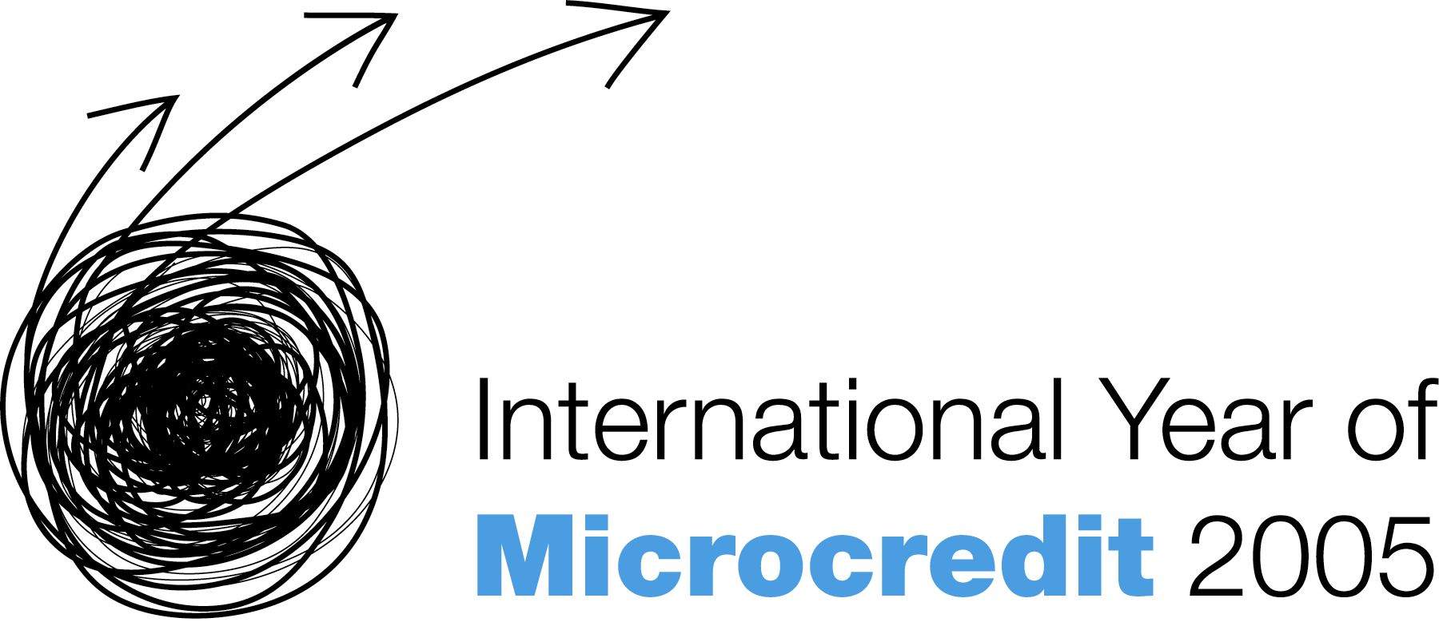
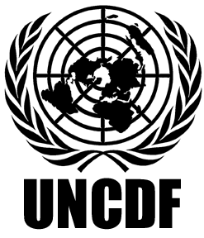
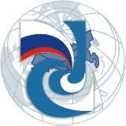
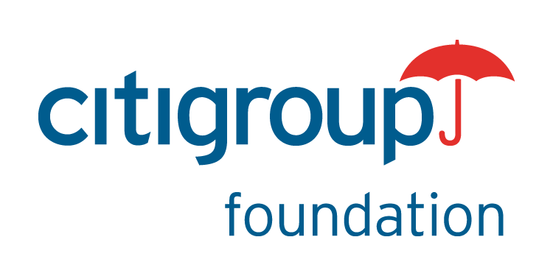
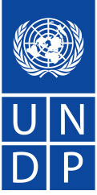

"Global Microentrepreneurship Awards” Competition for the First Time in Russia

Moscow, 25 August 2005 – Today in Moscow, the first international “Global Microentrepreneurship Awards” (GMA) competition was launched. The competition is aimed at highlighting achievements of the most successful micro-entrepreneurs and the most effective organizations working in the area of microfinance from all regions of Russia and to raise awareness of the society and authorities about the sphere of microfinance.
In Russia, the competition is organized by the United Nations Development Programme (UNDP), Citigroup Russia and the Russian Microfinance Center (RMC). The competition will be held under the auspices of the Council on the International Year of Microcredit 2005 under the Ministry of Economic Development and Trade of the Russian Federation.
Ms. Kaarina Immonen, UNDP Resident Representative in the Russian Federation a.i.; Ms. Natalia Larionova, Head of Division of the State Economic Regulation Department of the Ministry of Economic Development and Trade of RF; Ms. Nataly Nikolaeva, Vice-President of Citibank Russia; and Mr. Mikhail Mamuta, Director of the Russian Microfinance Centre, took part in the press conference.
Ms. Kaarina Immonen opened the press-conference by saying that the main objective of the United Nations is to contribute to the achievement of the Millennium Development Goals in 2015, targeted primarily at alleviating poverty. “Microentrepreneurship is an effective instrument for achieving these goals. A several hundred dollars loan can give a person an opportunity to build his own enterprise and lift him out of poverty.”
“Global Microentrepreneurship Awards” Programme in Russia is an important step in the promotion of microfinance as an instrument for new enterprises and jobs creation. The Programme has our full support and we hope that the competition will be a success,” Nataly Nikolaeva noted.
According to Mr. Mikhail Mamuta, Director of the Russian Microfinance Centre, “the implementation of the Programme will have a positive effect on development of the microfinance sector that will trigger an increase in small enterprise crediting.”
Applications will be accepted from 25 August till 7 October. Applications are made by microfinance organizations on behalf of their clients. The jury includes representatives of the Chamber of Commerce and Industry of the Russian Federation, Ministry of Economic Development and Trade of the Russian Federation, Higher School of Economics, United Nations Development Programme, ZAO Citibank, Russian Microfinance Center, Vneshtorgbank, New Eurasia Foundation, Women’s Microfinance Network, OPORA of Russia, League of Credit Unions, Union of Agricultural Credit Cooperatives, Resource Centre for Small and Medium Enterprises, National Union of Financial Support Organizations, Russian Agency for Small and Medium Enterprises.
Prizes will be awarded in the following nominations:
- Best microentrepreneur among non-trade enterprises
- Best microentrepreneur among trade enterprises
- Best employer in the area of microentrepreneurship among non-trade enterprises
- Best employer in the area of microentrepreneurship among trade enterprises
Prizes for microfinance organizations will be awarded in “The most effective microfinance programme to support entrepreneurship” category. Loan officers who worked with winners of thecompetition among microentrepreneurs will receive prizes.
The GMA awards ceremony will take place on 1 December 2005 in St.Petersburg at the IV National Conference “Microfinance in Russia: Successful Strategies for Economic Growth.”
The United Nations General Assembly has declared 2005 the International Year of Microcredit in order to highlight the impact of microfinance on poverty alleviation. In November 2004, to commemorate the launch of the International Year of Microcredit, the United Nations Capital Development Fund, the Citigroup Foundation (the philanthropic arm of Citigroup), and a group of professionals from a number of universities united to organize business competitions for microentrepreneurs. In 2004 the “Global Microentrepreneurship Awards” competition for the first time was held in 8 countries (Afghanistan, Cambodia, the Dominican Republic, Indonesia, Mexico, Mozambique, Pakistan, and Rwanda); also, a local competition took place in New York. This year the GMA competitions will be held in 30 countries including Russia.
For more information on the competition and microfinanсе in Russia please contact Elena Selyuk at UNDP at 7 (501) 414 0827, e-mail Elena.Selyuk@undp.org, visit the United Nations Development Programme website www.undp.ru or Russian Microfinance Centre website www.rmcenter.ru
***
United Nations Development Programme (UNDP) is the UN's global development network, advocating for change and connecting countries to knowledge, experience and resources to help people build a better life. We are on the ground in 166 countries, working with them on their own solutions to global and national development challenges. As they develop local capacity, they draw on the people of UNDP and our wide range of partners.
Citigroup (NYSE: C), the leading global financial services company, has some 200 million customer accounts and does business in more than 100 countries, providing consumers, corporations, governments and institutions with a broad range of financial products and services, including consumer banking and credit, corporate and investment banking, insurance, securities brokerage, and asset management. Major brand names under Citigroup's trademark red umbrella include Citibank, CitiFinancial, Primerica, Smith Barney and Banamex. Additional information may be found at www.citigroup.com
For more information please contact Natalia Myshko, PR Manager, ZAO KB Citibank at +7 (095) 598 2925 or by e-mail Natalia.Myshko@citigroup.com
The Russian Microfinance Center (RMC) works to develop a dynamic and self-liquidating microfinance sector in the Russian Federation through a series of activities designed to provide essential information and services to microfinance professionals and other interested institutions and individuals regardless of form of incorporation, size and location. RMC offers support and assistance to all microfinance organizations. Through this work, the RMC aims to promote further development of the microfinance industry in Russia to make a meaningful contribution to Russia’s economic and social development.

