Weekly Email Index

2005.11.10

Citigroup news>>Press Release
No | 媒体名称  Publication | 日期  Date | 版面  Page | 发行量  Circulation | 城市  Coverage | 面积  Size | 文章标题  Headline | 基调  Tone | 广告价格  Ad.Equ.
1 | 新浪  www.sina.com.cn | 2005.11.08 | Web | n/a | Beijing | n/a | 图文：“全球微型创业奖”在京颁奖  The awards ceremony for the "Global Microentrepreneurship Award" held in Beijing | + | n/a
2 | 中华工商时报  China Business Times | 2005.11.09 | 03b | 350,000 | Beijing | 88 | “全球微型创业奖”出炉  Winners of the "GMA" announced | + | 6,776
3 | 中国日报  China Daily | 2005.11.09 | 10b | 300,000 | Beijing | 176 | 贷款帮助小企业  Loans aim to help small enterprises | + | 14,608
4 | 证券时报  Securities Times | 2005.11.09 | 02 | 500,000 | Guangdong/  Shenzhen | 54 | 中国“全球微型创业奖”在京揭幕  Winners of the "GMA" announced in Beijing | + | 7,074
5 | 新京报  The Beijing News | 2005.11.09 | b01a | 400,000 | Beijing | 270 | 馄饨老板徐晓恩等获“中国全球微型创业奖”  Xiu Xiao'en, owner of a wonton shop, wins "GMA" awards | + | 28,350
6 | 搜狐  www.sohu.com | 2005.11.09 | Web | n/a | Beijing | n/a | 联合国开发计划署已向逾30万中国客户发放小额贷款  At least 300,000 Chinese clients have received loans from the UNDP Microcredit project | + | n/a

News Clipping from China top
Headline: The awards ceremony for the "Global Microentrepreneurship Award" held in Beijing 图文：“全球微型创业奖”在京颁奖
Publication: www.sina.com.cn 新浪
Paper Date: 2005.11.08
Page: http://news.sina.com.cn/c/p/2005-11-08/17078246137.shtml
Journalist(s): Chen Jianli
________________________________________________________________________________________
Summary: Nov. 8, The United Nations Development Programme (UNDP) and Citigroup Foundation announce the winners of the first-ever Global Microentrepreneurship Awards (GMA) in Beijing. A total of 25 people were selected as winners across nine categories. The United Nations has declared 2005 the International Year of Microcredit. The GMA initiative is a key element of this world understanding.

图文：“全球微型创业奖”在京颁奖
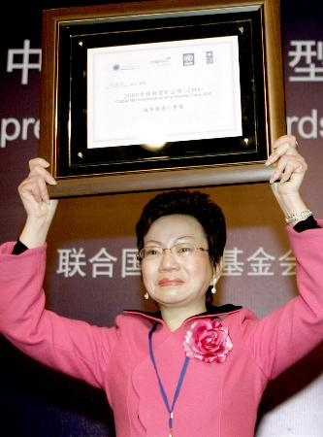

11月8日，依靠小额信贷的支持从下岗工人起步致富的四川德阳市市民张荣芳，在北京举行的“全球微型创业奖”颁奖仪式上含泪领奖。当日，联合国开发计划署、花旗集团基金会等在北京举行颁奖仪式，对来自全国的25名利用国际小额信贷而脱贫的微型创业者进行表彰。联合国将2005年定为国际小额信贷年，“全球微型创业奖”为其中的部分内容。这也是“全球微型创业奖”项目首次在中国实施。
新华社记者陈建力摄

News Clipping from China top
Headline: Winners of the "GMA" announced “全球微型创业奖”出炉
Publication: China Business Times 中华工商时报
Paper Date: 2005.11.09
Page: 03b
Journalist(s): Zhou Rongxiang
________________________________________________________________________________________
Summary: The winners of the first-ever Global Microentrepreneurship Awards (GMA) are announced on Nov. 8. Twenty-five people were selected as winners within the nine categories. The GMA program is supported by The United Nations Development Bank Programme (UNDP) and Citigroup Foundation, the philanthropic arm of Citigroup. Twenty-five people were selected as winners within the nine categories.

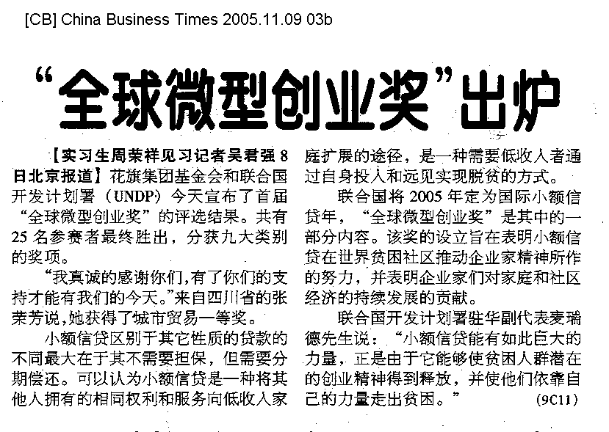

News Clipping from China top
Headline: Loans aim to help small enterprises 贷款帮助小企业
Publication: China Daily 中国日报
Paper Date: 2005.11.09
Page: 10b
Journalist(s): Jiang Jingjing
________________________________________________________________________________________
Summary: Citigroup Foundation and the United Nations Development Programme (UNDP) aim to promote the issuance of small loans to China's numerous small enterprises and business individuals. The two organizations yesterday announced the winners of the first-ever Global Microentrepreneurship Awards in China. A total of 292 applicants participated in the awards assessment around China, and 25 people were selected as winners within the nine categories. Richard Stanley, CEO of Citigroup China, noted that Citigroup wishes that such a program would serve to recognize and promote the role of microfinance in China's ongoing social and economic development.

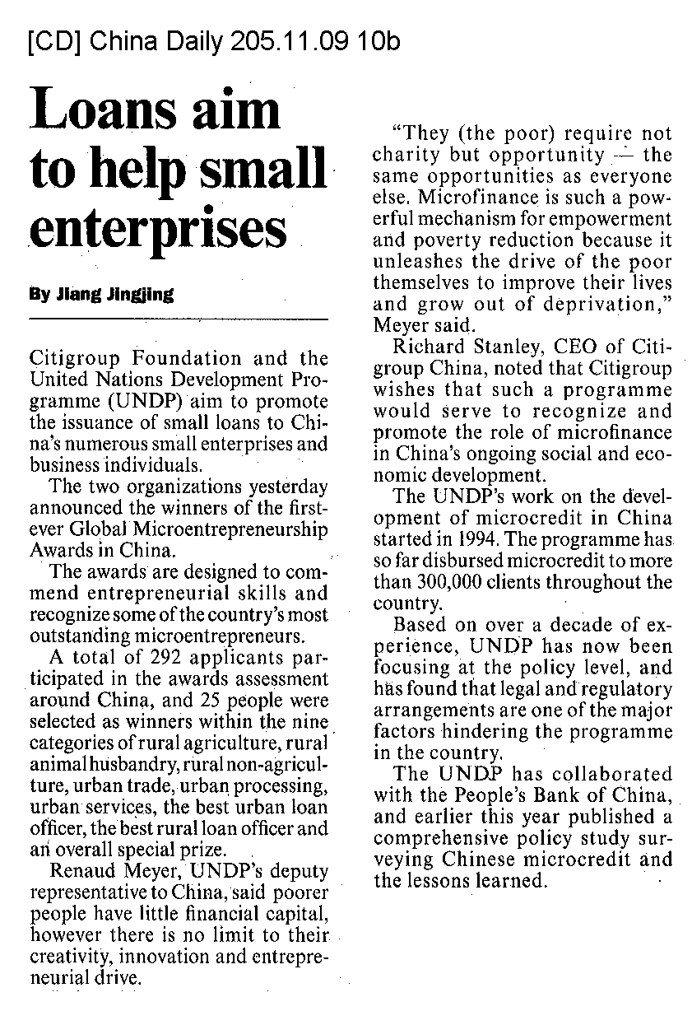

News Clipping from China top
Headline: Winners of the "GMA" announced in Beijing 中国“全球微型创业奖”在京揭幕
Publication: Securities Times 证券时报
Paper Date: 2005.11.09
Page: 02
Journalist(s): Liu Yang
________________________________________________________________________________________
Summary: The winners of the first-ever Global Microentrepreneurship Awards (GMA) are announced in Beijing. The GMA program is supported by The United Nations Development Bank Programme (UNDP) and Citigroup Foundation, the philanthropic arm of Citigroup. Twenty-five people were selected as winners within the nine categories.

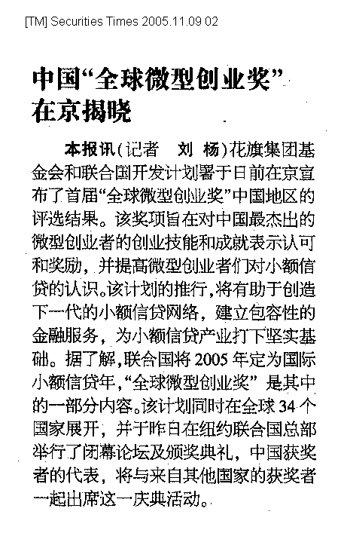

News Clipping from China top
Headline: Xiu Xiao'en, owner of a wonton shop, wins "GMA" awards 馄饨老板徐晓恩等获“中国全球微型创业奖”
Publication: The Beijing News 新京报
Paper Date: 2005.11.09
Page: b01a
Journalist(s): Zhuang Shiguan and Yang Jie
________________________________________________________________________________________
Summary: The winners of the first-ever Global Microentrepreneurship Awards (GMA) are announced Nov. 8. The GMA program is supported by the United Nations Development Bank Programme (UNDP) and Citigroup Foundation, the philanthropic arm of Citigroup.

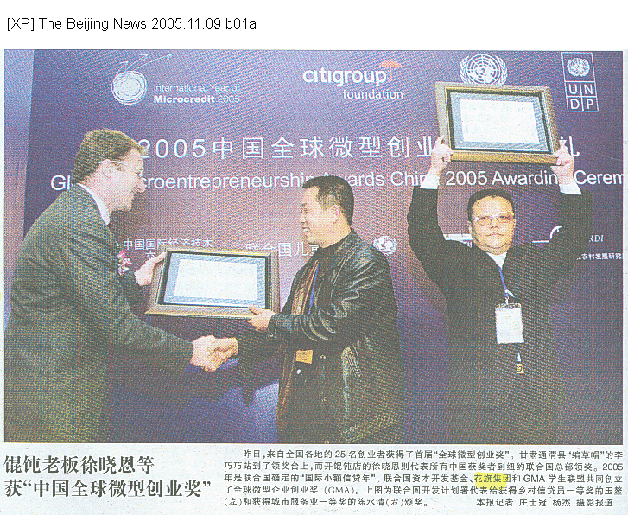

News Clipping from China top
Headline: At least 300,000 Chinese clients have received loans from the UNDP Microcredit project 联合国开发计划署已向逾30万中国客户发放小额贷款
Publication: www.sohu.com 搜狐
Paper Date: 2005.11.09
Page: http://news.sohu.com/20051108/n227430454.shtml
Journalist(s): Wang Weiping
________________________________________________________________________________________
Summary: Nov. 8, during a press conference, the Citigroup Foundation and United Nations Development Programme (UNDP) announce the winners of the first-ever Global Microentrepreneurship Awards (GMA) in China. A total of 25 people are selected as winners because of their outstanding achievements in the rural agriculture, rural animal husbandry, rural non-agricultural and urban trade fields.

联合国开发计划署已向逾30万中国客户发放小额贷款

时间：2005年11月08日22:32 来源：新华网

新华网北京11月8日电（记者王卫平）记者8日从此间举行的新闻发布会上获悉，联合国开发计划署至今已向中国各地超过30万客户发放了小额贷款，总投入接近2000万美元。
1994年，联合国开发计划署开始在中国发展小额信贷，由中国国际经济技术交流中心提供支持和协调，首先在云南建立了基层农村发展协会，后来逐渐发展到16个省区的48个县。
据介绍，除了发放贷款，联合国开发计划署还支持能力发展项目，旨在为贷款者提供工作和生活的技巧，使他们了解贷款所有的潜在作用。由于战略清晰，项目最终取得了良好的贷款回收率，表明小额信贷在中国成为能够有效减少贫困的方式。
新闻发布会上，花旗集团基金会与联合国开发计划署共同向25名普通中国人颁发了“全球微型创业奖”，表彰他们在乡村种植业、乡村养殖业、乡村非农业和城市贸易等方面作出的成绩。
联合国将2005年定为国际小额信贷年，评选“全球微型创业奖”是其中的一部分内容，该计划同时在34个国家展开。

